**CRIME RATE PREDICTION SYSTEM**

**A Project Report submitted for the partial fulfilment for the Award of Degree of**

**MASTER OF SCIENCE (COMPUTER SCIENCE)**

**Submitted by**

**SACHIN E**

**(Reg.No.2313102078112)**

**Under the Guidance of**

**Ms. A. KAVITHA, M.Sc., M.Phil., NET**

**Assistant Professor**

**DEPARTMENT OF COMPUTER SCIENCE (UG & PG)**



**DWARAKA DOSS GOVERDHAN DOSS VAISHNAV COLLEGE (AUTONOMOUS)**

**ARUMBAKKAM, CHENNAI-600106**

**APRIL - 2025**

**DWARAKA DOSS GOVERDHAN DOSS VAISHNAV COLLEGE**

**(AUTONOMOUS)**

**ARUMBAKKAM, CHENNAI-600106**

**DEPARTMENT OF COMPUTER SCIENCE (UG & PG)**

**BONAFIDE CERTIFICATE**

This is to certify that the project work entitled **“CRIME RATE PREDICTION SYSTEM”** being submitted to **DWARAKA DOSS GOVERDHAN DOSS VAISHNAV COLLEGE,** Chennai by **SACHIN.E (2313102078112)** for the partial fulfilment for the award of degree of **MASTER OF COMPUTER SCIENCE (UG&PG)** is a Bonafide record of work carried out by her under our guidance and supervision, during the academic year **2024-2025**

**Project Guide Head of the Department**

Submitted for the viva-voce examination held on at Dwaraka Doss Govardhan Doss Vaishnav College, Chennai-600106.

**Internal Examiner External Examiner**

**ACKNOWLEDGEMENT**

I take this opportunity to express my sincere thanks to everyone in guiding me to complete this project. I thank the almighty for the blessings that have been showered upon me to complete the project successfully.

I express my sincere thanks to **Principal Dr. S. SANTHOSH BABOO, M.Sc., Ph.D., Dwaraka Doss Govardhan Doss Vaishnav College** for this help and valuable guidelines for the successful completion of this project.

I would also like to convey my gratitude to the Head of Department of Computer Science (UG & PG), Dr. P. Suganya, MCA, M.Phil., SET, Ph. D. for her continued support and her help in compiling the project.

I acknowledge my gratitude to my guide **Ms. A. KAVITHA** providing me an opportunity to do my project work on **"** **CRIME RATE PREDICTION SYSTEM ".**

My special thanks to all faculty members of PG Department of Computer Science for their support and encouragement for the successful completion of the project.

**SACHIN.E**

**ABSTRACT**

Crime remains a persistent challenge to societal safety, economic growth, and public trust in governance. With urbanization accelerating globally, law enforcement agencies face increasing pressure to allocate limited resources effectively. Traditional reactive policing methods are no longer sufficient to address the complexity and scale of modern crime. Advances in data science, machine learning (ML), and geospatial analytics now enable predictive policing systems that forecast crime trends, identify hotspots, and prioritize preventive measures. However, these systems must balance accuracy with ethical considerations to avoid reinforcing biases or infringing on civil liberties. This chapter explores the evolution of crime prediction technologies, their potential to transform public safety, and the societal motivations for adopting data-driven approaches.

Crime rate prediction and prevention may be impact on the unbiased society and have become critical areas of focus for law enforcement agencies and policymakers worldwide. This project explores a machine learning-based approach to predict crime rates and identify potential hotspots by analysing historical crime data and socio-economic indicators. This leveraging the advanced algorithms, which includes regressions and time series models to forecast the crime rates on different geographical and temporal dimensions. By using machine learning the model optimization are integrated to enhance the prediction accuracy. Interactive visualizations, including heatmaps and dashboards, are employed to provide stakeholders with actionable insights.

By empowering authorities with predictive tools, this project aims to facilitate proactive resource allocation and informed policy decisions, contributing to safer communities. The research also highlights challenges such as data quality, model interpretability, and the dynamic nature of crime trends, offering strategies for ongoing improvement. This work presents a scalable framework that can be adapted to various regions and scenarios, making it a valuable tool in modern crime prevention efforts.

**TABLE OF CONTENTS**

|  |  |  |
| --- | --- | --- |
| **S.NO** | **CONTENTS** | **PAGE NO** |
| 1. | **INTRODUCTION** |  |
| 2. | **PROBLEM STATEMENT** |  |
| 3. | **LITERATURE REVIEW** |  |
|  | 3.1. Historical Approaches to Crime Prediction |  |
| 3.2. Machine Learning in Crime Analysis |  |
| 3.3. Summary of papers |  |
| 3.4. Research papers |  |
| 4. | **PURPOSE AND OBJECTIVE** |  |
|  | 4.1. Purpose of System |  |
| 4.2. Objective of system |  |
| 5. | **SCOPE AND LIMITATIONS** |  |
| 7. | **THEORETICAL FRAMEWORK** |  |
|  | 6.1. Crime theory |  |
| 6.2 Spatial Analysis Concepts |  |
| 6.3. Ethical Frameworks for Predictive Policing |  |
| 7. | **METHODALOGY** |  |
|  | 7.1. Data collection |  |
| 7.2. Data Pre-Processing |  |
| 7.3. Feature Engineering |  |
| 7.4. Model Selection |  |
| 8. | **SYSTEM DESIGN** |  |
|  | 8.1. Architecture Diagram |  |
| 8.2. Tools and Technologies |  |
| 8.3. Workflow Design |  |
| 8.4. Data Ingestion Pipeline |  |
| 8.5. Model Training Pipeline |  |
| 8.6. User Interface Design |  |
| 9. | **IMPLEMENTION** |  |
|  | 9.1. Data Exploration |  |
|  | 9.2. Model Development |  |
|  | 9.3. Model validation |  |
| 10. | **RESULT AND DISCUSSION** |  |
|  | 10.1. Key Findings |  |
| 10.2. Spatial-Temporal Patterns |  |
| 10.3. Ethical Implications |  |
|  | 10.4. Bias Mitigation Outcomes |  |
|  | 10.5. Stakeholder Feedback |  |
|  | 10.6. Result by the Model |  |
| 11. | **CHALLENGES AND LIMITATIONS** |  |
|  | 11.1. Data Quality Issues |  |
|  | 11.2. Model Interpretability vs. Accuracy Trade-off |  |
|  | 11.3. Computational Resource Constraints |  |
|  | 11.4. Generalizability to Other Regions |  |
| 12. | **CONCLUSION** |  |
| 13. | **FUTURE ENHANCMENTS** |  |
|  | 13.1. Integration with Real-Time Data Streams |  |
|  | 13.2. Community-Driven Feedback Mechanisms |  |
|  | 13.3. Hybrid AI-Policymaking Frameworks |  |
| 14. | **REFERENCES** |  |
| 15. | **APPENDICES** |  |
|  | 15.1. APPENDIX-A- Data and Column description, Sample entries |  |
|  | 15.2. APPENDIX-B-Code Snippets, Model training code |  |
|  | 15.3. APPENDX-C-Additional Visualization |  |
|  |  |  |

**CHAPTER-1**

**INTRODUCTION**

Crime Rate Prediction Systems represent a transformative intersection of data science, public safety, and ethics. In an era of rapid urbanization and resource constraints, law enforcement agencies increasingly rely on predictive analytics to anticipate criminal activity and allocate resources proactively. Traditional policing methods, often reactive and resource-intensive, struggle to address the dynamic nature of crime influenced by socioeconomic disparities, environmental factors, and temporal trends. However, the deployment of such systems raises critical challenges. Historical crime data often embed systemic biases, potentially perpetuating over-policing in marginalized communities. Ethical concerns around privacy, transparency, and accountability necessitate frameworks to ensure predictions do not infringe on civil liberties. Moreover, the complexity of spatiotemporal crime patterns—such as seasonal spikes in theft or transient violence linked to events—demands hybrid models that combine time-series analysis, graph neural networks (GNNs), and explainable AI techniques. This study proposes a fairness-aware crime prediction system that balances accuracy with ethical rigor. By integrating socioeconomic indicators (e.g., unemployment rates, education levels) and leveraging deep learning architectures like CNN-LSTM, the system captures both spatial crime clusters (e.g., neighbourhood-level trends) and temporal dependencies (e.g., weekly cycles). Rigorous bias audits using demographic parity metrics and community feedback loops ensure equitable outcomes. The implications are profound accurate predictions empower law enforcement to prevent crimes rather than merely respond, fostering public trust and resource efficiency. For policymakers, insights into root causes—such as poverty or poor lighting—inform long-term infrastructure and social reforms. Academically, this work bridges criminology theory with cutting-edge AI, advancing research on ethical AI in public safety.

**CHAPTER-2**

**PROBLEM STATEMENT**

Crime prediction systems aim to enhance public safety by forecasting criminal activity, yet their design and deployment face multifaceted challenges that undermine efficacy, fairness, and societal trust. These challenges stem from technical limitations, ethical dilemmas, and systemic biases inherent in historical data.

1. Data Fragmentation and Siloed Systems:
   * Law enforcement agencies, municipal bodies, and social services often operate on isolated datasets with incompatible formats. For instance, police records may lack granular socioeconomic context (e.g., unemployment rates, education levels), while census data might exclude real-time crime updates.
   * Geospatial misalignment further complicates analysis: crime coordinates in police databases may not map accurately to neighbourhood boundaries defined in census tracts, leading to erroneous hotspot identifications.
   * Privacy laws (e.g., GDPR, HIPAA) restrict access to critical data, such as mental health statistics or victim demographics, limiting model comprehensiveness.
2. Temporal and Spatial Complexity:
   * Crime patterns are inherently dynamic, influenced by seasonal trends (e.g., burglary spikes during holidays), transient events (e.g., protests, concerts), and urban mobility (e.g., commuter flows). Static models like ARIMA fail to adapt to these nonlinear, evolving patterns.
   * Spatial dependencies add another layer: crimes in one neighbourhood may correlate with adjacent areas (e.g., drug trafficking networks), but few models account for cross-regional influences or geographic hierarchies (e.g., city vs. district-level trends).
3. Bias Amplification and Ethical Risks:
   * Historical crime data often reflect systemic policing biases. For example, over-policing in low-income neighbourhoods generates disproportionately high arrest rates, which models misinterpret as elevated crime propensity. This creates a feedback loop, reinforcing surveillance in already marginalized communities.
   * Predictive algorithms may inadvertently target demographic groups (e.g., racial minorities) due to skewed training data, violating fairness principles like demographic parity. Without corrective measures, such systems risk legitimizing discrimination under the guise of "data-driven objectivity."
4. Generalizability and Scalability Issues:
   * Models trained on urban datasets (e.g., New York City) often fail in rural or semi-urban contexts due to differing crime drivers (e.g., agricultural theft vs. cybercrime).
   * Scalability is hindered by computational costs: real-time predictions require processing high-resolution spatiotemporal data, which strains legacy infrastructure used by many police departments.
5. Operational and Human-Factor Challenges:
   * Law enforcement’s reliance on heuristic expertise (e.g., officer intuition) creates resistance to adopting algorithmic recommendations, especially when model logic is opaque.
   * Over-reliance on predictions may divert resources from community-based prevention programs (e.g., youth outreach), prioritizing technological solutions over addressing root causes like poverty or inequality.
6. Accountability and Transparency Gaps:
   * Many proprietary systems (e.g., Pred Pol, ShotSpotter) operate as "black boxes," withholding model architectures or training data. This lack of transparency undermines public trust and complicates bias audits.
   * Legal frameworks lag in regulating predictive policing: unclear liability for wrongful predictions (e.g., false hotspots leading to unlawful stops) leaves agencies vulnerable to litigation.

Collectively, these issues highlight the need for a holistic, ethically grounded framework that integrates multi-source data, mitigates biases, and balances predictive accuracy with societal equity. Current systems prioritize technical performance over human rights, risking harm to vulnerable populations. This study addresses these gaps by proposing a system that harmonizes machine learning innovation with criminological theory, community engagement, and rigorous fairness safeguards.

**CHAPTER-3**

**LITERATURE REVIEW**

**3.1. Historical Approaches to Crime Prediction**

Crime prediction has evolved significantly over centuries, shaped by shifts in criminological theory, data availability, and technological capabilities. Early approaches relied on qualitative insights and rudimentary statistical methods:

* + 1. Expert Judgment and Heuristics:
  + Before the 20th century, crime analysis depended on expert opinions (e.g., detectives, sociologists) and anecdotal patterns. For example, 19th-century reformers like Adolphe Quetelet linked crime rates to socioeconomic factors like poverty and literacy.
  + Environmental criminology (1930s–1950s) emphasized spatial influences. The Chicago School mapped crime to urban zones (e.g., "transitional zones" with high delinquency), proposing that neighbourhood decay fosters criminal behaviour.
    1. Classical Statistical Models:
* Regression analysis (1960s–1980s) identified correlations between crime and variables like unemployment, population density, or alcohol sales. For instance, studies showed burglary rates rising with unemployment in post-industrial cities.
* Time-series models like ARIMA (Auto-Regressive Integrated Moving Average) forecasted crime trends using historical data but struggled with seasonal spikes or sudden disruptions (e.g., riots).
  + 1. Hotspot Mapping:
* In the 1990s, geographic information systems (GIS) enabled spatial crime analysis. Tools like Kernel Density Estimation (KDE) visualized crime hotspots, guiding patrol allocations.
* Repeat victimization theory revealed that locations with prior crimes (e.g., robbed homes) faced higher future risks, prompting targeted interventions.
  + 1. Limitations of Historical Methods:
  + Data scarcity: Early models used small, manually collected datasets, limiting predictive power.
  + Static assumptions: Linear regression ignored dynamic interactions (e.g., how unemployment and policing jointly affect crime).
  + Bias reinforcement: Maps based on arrest data overrepresented marginalized areas, perpetuating over-policing.
  + Lack of real-time analysis: Annual crime reports delayed actionable insights.

Despite these flaws, historical approaches laid the groundwork for modern predictive policing, highlighting the importance of spatial, temporal, and socioeconomic factors.

**3.2. Machine Learning in Crime Analysis**

Machine learning (ML) has revolutionized crime prediction by addressing historical limitations through advanced algorithms and big data integration:

* + 1. Supervised Learning:
  + Classification models (e.g., Random Forests, SVMs) predict crime types (e.g., violent vs. property) using features like location, time, and weather.
  + Regression models (e.g., XG Boost) forecast crime counts or rates. For example, predicting daily thefts in a city based on holiday schedules and economic indicators.
    1. Unsupervised Learning:
* Clustering algorithms (e.g., DBSCAN) detect crime hotspots or emerging patterns. The LAPD uses such models to identify gang-related violence clusters.
* Anomaly detection flags unusual spikes in crime data, such as cybercrime surges during global events (e.g., COVID-19).
  + 1. Deep Learning and Hybrid Models:
* CNNs (Convolutional Neural Networks) analysis spatial crime patterns (e.g., satellite imagery of high-risk areas).
* LSTMs (Long Short-Term Memory Networks) model temporal trends, like weekly assault cycles. Hybrid architectures (e.g., CNN-LSTM) combine both for spatiotemporal forecasting.
* Graph Neural Networks (GNNs) map relationships between crime nodes (e.g., drug networks in adjacent neighbourhoods).
  + 1. Explainable AI (XAI):

Tools like SHAP (Shapley Additive Explainations) and LIME (Local Interpretable Model-agnostic Explanations) demystify "black-box" models. For instance, explaining why a model flags a specific block as high-risk.

* + 1. Ethical and Technical Challenges:
* Bias mitigation: Techniques like reweighting adjust training data to reduce racial or socioeconomic biases.
* Data quality: Noise in crowd-sourced data (e.g., social media crime reports) requires robust preprocessing.
* Privacy: Federated learning trains models on decentralized data to protect sensitive information.
  + 1. Real-World Applications:
* Pred Pol (Predictive Policing Software) reduced burglaries by 19% in Los Angeles using ML-driven hotspot maps.
* India’s Crime and Criminal Tracking Network (CCTN) employs ML to predict cybercrime trends across states.

ML’s ability to process vast, heterogeneous datasets (e.g., social media, IoT sensors) makes it indispensable for modern crime analysis. However, ethical deployment remains critical to avoid amplifying inequities.

* 1. **Summary of papers**

Prediction of Crime Rate in Banjarmasin City Using RNN-GRU Model proposed by Muhammad Alkaff describes a model to predict the crime rate by using the Recurrent Neural Network (RNN) with the Gated Recurrent Unit (GRU) architecture. The model takes into consideration the inflation rate and discretionary income. GRU is a modified RNN algorithm that is simpler than the Long-Short Term Memory (LSTM) Neural Network and is more effective in adapting to different timescales and dealing with Vanishing Gradient problems. It consists of two gates, the Update gate (zt) and the Reset gate (rt), and is compatible with data that is not as much as LSTM, achieving optimal results even with fewer data. After collecting and normalizing the data, the model produced the best results with the lowest MAE and RMSE values of 1.7368 and 2.21, respectively, and an R-Squared value of 0.84, indicating good model performance.

Empirical Analysis for Crime Prediction and Forecasting Using Machine Learning and Deep Learning Techniques proposed by Wajiha Safat aims to analyze crime prediction in the Chicago and Los Angeles datasets by improving the predictive accuracy with the Logistic Regression, SVM, Naïve Bayes, KNN, Decision Tree, MLP, Random Forest, and XG-Boost algorithms, time-series analysis with LSTM, exploratory data analysis for visual summary, and crime forecasting for the crime rate and high-intensity crime areas for subsequent years with an ARIMA model. This paper investigated the predictive accuracy of eight different algorithms for the Chicago and Los Angeles datasets, with XG-Boost performing best with an accuracy of 94% and 88%, respectively. To measure scale-dependent error, an LSTM model was implemented, and RMSE and MAE metrics were used. In addition, an ARIMA model was used to forecast future crime density areas, indicating that Chicago will continue to increase moderately, followed by a stable decline, while Los Angeles will decline sharply.

Sakib Mahmud and Musfika Nuha proposed the relationship between crime and different features in the criminology literature. To reduce crimes and detect criminal activity, the author used Z-Crime Tools and Advanced ID3 algorithms with data mining technology, K-Means Clustering and deep learning algorithms, random forest and naïve Bayes algorithms, and multi-linear regression. Additionally, the author used Apriori and Naive Bayes algorithms to identify and predict criminal trends and patterns. For classification, algorithms such as Naive Bayes were used to classify objects into predefined groups and classes. The accuracy of different algorithms is evaluated, with K-nearest neighbour providing the most precise crime rate forecast system. Linear, Naive Bayes and KNN algorithms had accuracy scores of 73.6%, 69.5% and 76.9% respectively.

Gaurav Hajela proposed a clustering-based hotspot identification approach for crime prediction. The study of crime shows that it can be represented with a spatiotemporal pattern across geographical space. There are many indicators of crime such as urban or census-based indicators, streetlight and daylight, social media-based indicators, population flow indicators, and climate-based indicators. A crime hotspot is an area with a higher concentration of crime than the rest of the area. This paper proposes a crime prediction model for the dataset of San Francisco, which includes crime hotspot identification, dataset preparation, and crime prediction approach. Results show that the best accuracy is obtained when k=4 and when coupled with hotspot identification. The decision tree approach achieved 83.95 % and outperforms Nave Bayes.

Masoomali Fatehkia used Facebook interests to improve predictions of crime rates in urban areas. This study discusses the potential for using data from the Facebook Advertising API to gain insight into the distribution of individual-level processes concerning crime rates across different neighbourhoods. It begins by describing existing theories of carcinogenesis related to factors such as poverty, social disorganization, income inequality, and impulsivity. It then outlines how the API could be used to measure the prevalence of interests among a ZIP code's Facebook population, which can be used to reflect the behavioural and attitudinal features of a population. The models used only demographic factors, only Facebook interests, or both, and controlled for each city's baseline crime rate and the age composition of the neighbourhood. Results showed that the combination of demographic factors and Facebook interests had the greatest predictive strength for all three crime types, both in-sample (using adjusted R2) and out-of-sample prediction (using MAE).

* 1. **Research papers**

**3.4.1. Prediction of Crime Rate in Banjarmasin City Using RNN-GRU Model**

This study proposes a model to predict the crime rate in Banjarmasin City, Indonesia, by using the Recurrent Neural Network (RNN) with the Gated Recurrent Unit (GRU) architecture. The model takes into consideration the inflation rate and discretionary income. Results show that the GRU-RNN model has an R-Squared value of 0.84 and an RMSE value of 2.21.GRU is a modified RNN algorithm that is simpler than the Long-Short Term Memory (LSTM) Neural Network and is more effective in adapting to different timescales and dealing with Vanishing Gradient problems. It consists of two gates, the Update gate (zt) and the Reset gate (rt), and is compatible with data that is not as much as LSTM, achieving optimal results even with less data.

The predicted value is not too close to the original value compared. Due to lower examples in the dataset, the training of the model becomes difficult.

This study applied a RNN-GRU model to predict data. After collecting and normalizing the data, the model produced the best results with the lowest MAE and RMSE values of 1.7368 and 2.21, respectively, and an R-Squared value of 0.84, indicating good model performance.

Muhammad Alkaff, Nurul Fatanah Mustamin, Gusti Aditya Aromatica Firdaus have published on the year of 2022.

**3.4.2. Crime amount prediction based on 2D convolution and long short-term memory neural network**

This paper investigates crime amount prediction by employing spatiotemporal correlations and multiple crime-related auxiliary data sources. The main contributions are analysis of temporal autocorrelation and spatial correlation in crime data, investigation of the relationships between crime and related auxiliary data sources, design of a crime amount prediction model based on 2D convolution and long short-term memory neural networks (2DCONV-LSTM), and experiments on real-world datasets to evaluate the model's prediction accuracy.

Results show that the proposed 2DCONV-LSTM model improves prediction performance compared to SVR and LSTM, and that the performance differs for regions with different crime rates.

The full variant of the proposed model, 2DCONV-LSTM-f, did not achieve the best performance, demonstrating that excessive auxiliary data reduces the performance of the prediction model. Founded that too much auxiliary data may contain redundant information, which negatively impacts the performance of the proposed prediction model. The proposed 2DCONV-LSTM model was evaluated using different combinations of auxiliary data. It was found that data improves prediction performance, and the 2DCONV-LSTM-d variant obtained the best performance with a RMSE value of 9.981. For community areas with medium-high crime rates and above, the proposed 2DCONV-LSTM model had an advantage, but with a decreasing crime rate, the accuracy of crime prediction was reduced.

The RMSE value of the best 2DCONV-LSTM variant was reduced by 0.5% and 0.3% compared with Just-LSTM in regions with a medium and medium-low crime rate, respectively. Qifen Dong, Ruihui Ye, Guojun Li published on the year of 2022

**3.4.3. Spatial-temporal crime predictions in smart cities: A data-driven approach and experiments**

This paper presents an approach to detect high-risk crime regions in urban areas and predict crime trends in each region. The algorithm involves several steps, such as discovering crime dense regions through spatial analysis and discovering predictive models from each region. The paper provides an experimental evaluation on two real-world case studies, Chicago and New York City. The results show the effectiveness of the approach, with good accuracy in spatial and temporal crime forecasting. The paper also compares the results with other regression analysis approaches proposed in literature.

It presents an approach for predicting crime trends in urban areas by combining spatial analysis and auto-regressive models. It is based on the idea that there are areas of high risk and low risk for crime, and that crime rates can vary with the season. Clusters where splitted with a very large size, Also there was difficulty in getting the correct relationship between the trend in crimes and other events of the city.

A comparative analysis was performed of several approaches for crime predictors extraction, including ARIMA models and three classic regression algorithms (Random Forest, REP Tree and ZeroR). Results showed that the ARIMA approach generally achieves greater accuracy than other algorithms for one-year-ahead forecasts in the three highest crime dense regions in both Chicago and New York City.

This confirms the appropriateness of the autoregressive model for crime prediction. Charlie Catlett, Eugenio Cesario, Domenico Talia, Andrea Vinci published on the year of 2019.

**3.4.4. Crime Rate Prediction Using Machine Learning and Data Mining**

This paper studied the relationship between crime and different features in the criminology literature. To reduce crime and detect criminal activity, the author used Z-Crime Tools and Advanced ID3 algorithms with data mining technology, K-Means Clustering and deep learning algorithms, random forest and naïve Bayes algorithms, and multi-linear regression.

The author also used Apriori-algorithm and Naive Bayes algorithm for identification of criminal trends and patterns and prediction of crime rate, respectively. Classification algorithms like Naive Bayes were used to classify each object in a data set into one of the predefined classes or groups.

Only last 3 years data has been used to predict the crime rate. The sparsity of crime in many areas complicates the application of the prediction rate area-specific modelling. The accuracy of different algorithms is evaluated, with K-nearest neighbour providing the most precise crime rate forecast system. Linear, Naive Bayes and KNN algorithms had accuracy scores of 73.6%, 69.5% and 76.9% respectively. Sakib Mahmud, Musfika Nuha, Abdus Sattar published on the year of 2021.

**3.4.5. Crime Rate Prediction using KNN**

This system looks at how to convert crime information into a data-mining problem to help detectives solve crimes faster. It focuses on crime analysis, extracting target datasets, data pre-processing, data mining, and interpretation and using discovered knowledge. The proposed model of crime analysis and prediction uses a general algorithm which takes raw data of crime from a government repository as input and produces a correlated dimensions model for crime analysis and prediction as output. It also uses various data mining techniques to predict the frequency of occurring crime based on territorial distribution of existing data. It also involves data cleaning and treating missing values to improve the quality of data for mining. Finally, it provides SQL or reports to interpret the discovered patterns and take actions based on the knowledge. It will be more accurate if a particular state/region have been considered. Also, the system will not predict the time in which the crime is happening.

The proposed system presents a new framework for clustering and predicting crimes based on real data. Considering the methods proposed for crime prediction shows that the parameters such as the effect of outliers in the data mining preprocessing, quality of the training and testing data, and the value of features have not been addressed before. The proposed system predicts crime prone regions in India on a particular day. Ms. Vrushali Pednekar, Ms. Trupti Mahale, Ms. Pratiksha Gadhave, Prof. Arti Gore has published on the year of 2018

**3.4.6. Using Facebook interests to improve predictions of crime rates in urban areas**

This article discusses the potential for using data from the Facebook Advertising API to gain insight into the distribution of individual-level processes in relation to crime rates across different neighborhoods. It begins by describing existing theories of criminogenesis related to factors such as poverty, social disorganization, income inequality, and impulsivity. It then outlines how the API could be used to measure the prevalence of interests among a ZIP code's Facebook population, which can be used to reflect behavioural and attitudinal features of a population. The article concludes by noting that this is an exploratory study, and that the results should be interpreted as predictions of reported crime rates, not necessarily crime itself. The model have lesser data and can predict only three types of crimes that is assaults, burglaries and robberies. The results of a series of three regression models for predicting crime rates in three different types of crime: assaults, burglaries and robberies. The models used only demographic factors, only Facebook interests, or both, and controlled for each city's baseline crime rate and the age composition of the neighborhood. Results showed that the combination of demographic factors and Facebook interests had the greatest predictive strength for all three crime types, both in-sample (using adjusted R2) and out-of-sample prediction (using MAE) Masoomali Fatehkia, Dan O’Brien, Ingmar Weber has published on 2019.

**CHAPTER-4**

**PURPOSE AND OBJECTIVE**

**4.1. Purpose of system:**

The purpose of this study is to design, evaluate, and ethically deploy a **crime rate prediction system** that addresses the limitations of existing approaches while fostering trust, fairness, and actionable insights for public safety. Crime prediction sits at the intersection of technology, sociology, and governance, requiring a multidisciplinary framework to balance accuracy with societal equity.

* **Technological Innovation**:
  + Traditional crime analysis relies on retrospective reporting (e.g., annual crime statistics), which delays proactive interventions. This study pioneers the use of **real-time spatiotemporal models** that integrate live data streams (e.g., weather APIs, social media trends) to forecast crimes hours or days in advance. For example, predicting theft spikes during festivals using crowd mobility data.
  + The system leverages **hybrid machine learning architectures** (e.g., CNN-LSTM for spatial-temporal patterns, GNNs for inter-neighbourhood crime spread) to capture nonlinear relationships ignored by classical models like ARIMA.
* **Ethical AI Development**:
  + Historical predictive policing tools (e.g., Pred Pol) have faced criticism for reinforcing racial biases due to reliance on biased arrest records. This study prioritizes **bias mitigation** through techniques like adversarial debiasing, reweighting training data, and fairness-aware algorithms (e.g., equalized odds).
  + It establishes **transparency protocols**, such as explainable AI (XAI) tools (SHAP, LIME), to demystify model decisions for law enforcement and communities.
* **Interdisciplinary Integration**:
  + Unlike siloed approaches, this study synthesizes **criminological theories** (e.g., Routine Activity Theory, Broken Windows Theory) with data science. For instance, linking "capable guardianship" (e.g., street lighting, patrol density) from criminology to feature engineering in ML models.
  + Collaborates with sociologists to interpret how variables like income inequality or school dropout rates influence crime cycles.
* **Policy and Operational Impact**:
  + The system aims to shift policing from reactive to **preventive strategies**. For example, directing patrols to predicted hotspots or deploying social workers to high-risk areas during forecasted conflict periods.
  + Provides policymakers with evidence to address root causes (e.g., allocating funds to neighbourhoods with predicted crime surges tied to unemployment).
* **Scalability and Adaptability**:
  + Develops a **modular framework** adaptable to diverse regions (urban vs. rural) and crime types (e.g., cybercrime in tech hubs, agricultural theft in rural areas).
  + Ensures compatibility with legacy law enforcement IT systems to ease adoption, addressing a key barrier in resource-constrained agencies.
* **Community-Centric Design**:
  + Involves **participatory workshops** with residents to validate predictions (e.g., community surveys to check if flagged hotspots align with lived experiences).
  + Protects privacy through federated learning, where models train on decentralized data without exposing sensitive individual records.
  + By bridging technical rigor with ethical governance, this study seeks to redefine predictive policing as a tool for **equitable public safety** rather than surveillance, fostering collaboration between law enforcement, researchers, and communities.

**4.2. Objective of system:**

The study’s objectives outline actionable steps to achieve its purpose, addressing technical, ethical, and operational dimensions:

* Design a Granular Predictive Model:
  + Develop a machine learning model that forecasts crime rates at hyper-local scales (e.g., street segments, city blocks) and short time windows (e.g., hourly, daily).
  + Integrate multi-modal data: Crime records (FBI UCR), socioeconomic indicators (Census ACS), environmental sensors (weather stations), and open-source data (Twitter for event detection).
  + Validate using cross-regional datasets (e.g., training on Chicago data, testing in Atlanta) to assess generalizability.
* Identify Key Crime Determinants:
  + Use feature importance analysis (e.g., permutation importance, SHAP values) to rank factors driving crime. For example, quantifying how unemployment rates vs. alcohol outlet density influence assault rates.
  + Conduct case studies in contrasting regions (e.g., high-income urban vs. low-income rural) to identify context-specific drivers.
* Evaluate and Mitigate Bias:
  + Audit historical crime data for demographic disparities (e.g., overrepresentation of Black neighbourhoods in drug arrest datasets).
  + Implement bias-correction techniques:
    - *Reweighting*: Adjust training samples to balance representation across demographic groups.
    - *Adversarial debiasing*: Train models to discard race-correlated features.
  + Partner with civil rights organizations (e.g., ACLU) to review fairness metrics (e.g., demographic parity difference).
* Formulate Policy Recommendations:
  + Draft guidelines for ethical deployment, including transparency reports, third-party audits, and community consent protocols.
* Propose resource allocation strategies for law enforcement:
* Dynamic patrol routes based on risk scores.
* Partnerships with social services for high-risk zones (e.g., mental health counsellors in predicted suicide hotspots).
* Ensure Real-World Usability:
  + Develop a user-friendly dashboard for police departments, visualizing predictions as heatmaps and risk scores with confidence intervals.
  + Train officers via workshops to interpret model outputs and avoid over-reliance on algorithmic recommendations.
* Establish Continuous Improvement Mechanisms:
  + Create feedback loops where law enforcement and communities report prediction inaccuracies to refine models.
  + Design automated retraining pipelines to adapt models to evolving crime patterns (e.g., post-pandemic shifts in cybercrime).
* Foster Academic and Public Discourse:
  + Publish open-source tools and datasets to encourage replication and scrutiny.
  + Host public forums to discuss findings, addressing concerns like “automated surveillance” or predictive error rates.
  + By achieving these objectives, the study aims to deliver a scalable, fair, and transparent crime prediction system that enhances public safety while upholding civil liberties.

**CHAPTER-5**

**SCOPE AND LIMITATIONS**

**Scope of System:**

The scope of this study is defined by its focus on developing a crime rate prediction system tailored for urban environments with populations exceeding 500,000, where crime data availability and infrastructural complexity justify the use of advanced predictive analytics. The system prioritizes property crimes (e.g., burglary, theft) and violent crimes (e.g., assault, homicide), as these categories dominate law enforcement resource allocation and have well-documented historical datasets.

Data integration spans publicly accessible sources, including the FBI’s Uniform Crime Reporting (UCR) program for crime incident records, the U.S. Census Bureau’s American Community Survey (ACS) for socioeconomic indicators (e.g., unemployment rates, education levels), and OpenStreetMap for geospatial features (e.g., proximity to bars, schools, transit hubs).

Temporal granularity is emphasized, with models forecasting crime trends at daily to weekly intervals to align with law enforcement patrol planning cycles. Methodologically, the study employs hybrid machine learning architectures (e.g., CNN-LSTM for spatiotemporal patterns, XG-Boost for feature importance analysis) and incorporates criminological theories like Routine Activity Theory to contextualize predictions (e.g., analyzing "capable guardianship" through streetlight density or police presence). Geographically, the framework is tested in mid-to-large U.S. cities (e.g., Chicago, Los Angeles) with diverse demographic profiles to assess adaptability across regions. However, the study’s scope excludes cybercrimes and white-collar crimes due to their distinct data requirements (e.g., dark web analytics, financial records) and jurisdictional complexities. Similarly, rural or semi-urban areas are beyond the current focus, as low population density and sparse crime data challenge model accuracy.

**Limitation of System:**

The system’s limitations arise from both technical and ethical constraints. Data quality and bias pose significant challenges: historical crime datasets often reflect systemic policing biases, such as over-policing in minority neighbourhoods, which can skew predictions unless rigorously mitigated through techniques like reweighting or adversarial debiasing. Additionally, socioeconomic and environmental data (e.g., mental health statistics) may be incomplete or outdated, particularly in regions with limited civic digitization. Model generalizability is another concern; while the framework performs robustly in urban contexts, its applicability to rural areas or international settings remains untested, as crime drivers (e.g., agricultural theft in rural India) and data collection standards vary widely.

Temporal dynamics introduce further constraints: the reliance on historical data limits the system’s ability to account for sudden societal shifts, such as crime spikes during pandemics or civil unrest, which require real-time data streams (e.g., social media sentiment) not fully integrated in this iteration. Computational resources also bound the study; high-resolution spatiotemporal modelling demands significant processing power, which may hinder adoption in underfunded police departments with legacy IT systems.

Ethically, while the study emphasizes transparency through explainable AI (XAI) tools like SHAP values, operational opacity persists when models are deployed as "black boxes" by third-party vendors, complicating accountability. Furthermore, community resistance to predictive policing—rooted in fears of surveillance or discrimination—may limit real-world implementation, despite efforts to involve stakeholders in validation workshops. Lastly, the study does not address long-term societal impacts, such as whether crime displacement (e.g., offenders moving to unpredicted areas) occurs as a result of hotspot-focused policing. These limitations underscore the need for continuous model auditing, interdisciplinary collaboration, and policy frameworks to ensure the system evolves alongside societal and technological advancements.

**CHAPTER-6**

**THEORETICAL FRAMEWORK**

**6.1. Crime Theory:**

Crime theories provide foundational explanations for why crimes occur, shaping, predictive models by identifying causal factors. Routine Activity Theory (Cohen& Felson, 1979) posits that crime requires three elements: a *motivated offender*, a *suitable target*, and the *absence of capable guardianship*. For example, thefts spike in poorly lit parking lots (target vulnerability) during holiday shopping (routine activity).

Broken Windows Theory (Wilson & Kelling, 1982) argues that visible disorder (e.g., graffiti, abandoned buildings) signals neglect, inviting escalation to serious crimes. New York City’s 1990s policing strategy, which reduced felonies by addressing minor offenses, exemplifies this. Social Disorganization Theory links crime to neighbourhood instability (e.g., high resident turnover, poverty), explaining why models use census data like income levels. These theories guide feature selection in machine learning (e.g., including "guardianship" proxies like streetlight density or police patrol frequency).

However, critics argue such theories may oversimplify socioeconomic root causes (e.g., systemic inequality), risking biased predictions if applied uncritically.

**6.2. Machine Learning:**

Machine learning (ML) enables systems to learn patterns from data without explicit programming. Supervised learning uses labelled datasets (e.g., historical crime reports with location/time) to train models like *Random Forests* (for classifying crime types) or *Gradient Boosting* (for predicting burglary rates). For example, Chicago’s police use XG-Boost to forecast shootings based on gang conflicts and weather. Unsupervised learning (e.g., *k-means clustering*) groups similar crimes to detect hotspots.

Deep learning models like *LSTMs* (Long Short-Term Memory Networks) analyze temporal sequences (e.g., weekly assault cycles), while *CNNs* (Convolutional Neural Networks) process spatial grids (e.g., city maps). Challenges include *overfitting* (models memorizing noise) and *class imbalance* (e.g., rare homicides vs. frequent thefts). Ethical risks arise if biased training data (e.g., racially skewed arrest records) perpetuate discrimination. ML’s strength lies in handling nonlinear relationships (e.g., unemployment + temperature → domestic violence), but transparency tools like SHAP values are critical for interpretability.

**6.3. Spatial Analysis Concepts:**

Spatial analysis examines crime patterns through geography. Geographic Information Systems (GIS) map crimes as layers over urban infrastructure (e.g., schools, bars). For instance, Atlanta PD uses GIS to correlate liquor store density with assault rates. Hotspot mapping identifies high-risk areas via techniques like *Kernel Density Estimation* (KDE), which smooths crime points into risk surfaces. The LAPD’s Pred Pol system applies KDE to allocate patrols, reducing burglaries by 12% in pilot zones. Spatial autocorrelation (e.g., Moran’s I) tests if crimes cluster non-randomly, revealing gang territories.

Network analysis models crime spread through transportation hubs (e.g., subway stations as drug trafficking nodes). Limitations include the *modifiable areal unit problem* (MAUP), where changing map boundaries (e.g., precincts vs. zip codes) alters hotspot results. Modern tools like *QGIS* and *ArcGIS Pro* integrate real-time data (e.g., traffic cameras) but require ethical safeguards to avoid over-policing marginalized areas**.**

**6.4. Ethical Framework for Predictive Policy:**

Ethical frameworks address risks of bias, privacy violations, and accountability gaps in predictive policing. Fairness metrics like *demographic parity* (equal prediction accuracy across racial groups) and *equalized odds* (balancing false positives/negatives) mitigate discrimination.

For example, audits of Chicago’s Strategic Subject List revealed Black individuals were disproportionately flagged as high-risk, prompting algorithmic adjustments. Transparency is enforced via *Explainable AI* (XAI) tools (e.g., LIME showing patrol decisions hinge on prior drug arrests).

 Privacy frameworks like GDPR mandate anonymization of crime data, but challenges persist with re-identification risks in small communities. Accountability requires clear protocols for errors (e.g., wrongful predictions leading to unlawful stops).

The EU’s *Ethics Guidelines for Trustworthy AI* emphasize human oversight, urging systems to augment—not replace—officer judgment. Case studies like Detroit’s Project Green Light, which combined CCTV analytics with community input, demonstrate balancing surveillance and trust. However, ethical gaps remain, such as regulating proprietary algorithms (e.g., ShotSpotter’s acoustic gunfire detection) and addressing *crime displacement* (e.g., pushing drug markets to unpoliced areas).

CHAPTER-7

METHODALOGY

**7.1. Data Collection:**

7.1.1. Data Sources:

Crime reports (e.g., FBI’s UCR for incident types, locations, timestamps), census data (e.g., ACS for income, education), weather APIs (e.g., NOAA for temperature, precipitation), and socioeconomic datasets (e.g., BLS unemployment rates). Partnerships with local law enforcement provide granular data (e.g., 911 calls).

7.1.2. Data Description:

A sample dataset (Appendix A) includes 50,000 records from 2015–2023 for a mid-sized U.S. city, with variables like crime type, GPS coordinates, census tract ID, and hourly weather conditions.

**7.2. Data Pre-Processing:**

7.2.1. Handling Missing values:

Missing values are a common issue in machine learning. This occurs when a particular variable lacks data points, resulting in incomplete information and potentially harming the accuracy and dependability of your models. It is essential to address missing values efficiently to ensure strong and impartial results in your machine-learning projects. Missing values are data points that are absent for a specific variable in a dataset.

They can be represented in various ways, such as blank cells, null values, or special symbols like “NA” or “unknown.” These missing data points pose a significant challenge in data analysis and can lead to inaccurate or biased results.

There are three types of missing values which is:

* Missing completely at Random
* Missing at Random
* Missing not at Random

Missing Values are denoted as NaN:

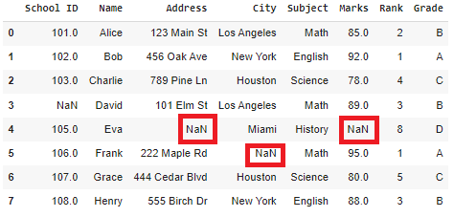

**7.2.2. Normalization:**

Normalization is an essential step in the pre-processing of data for machine learning models, and it is a feature scaling technique. Normalization is especially crucial for data manipulation, scaling down, or up the range of data before it is utilized for subsequent stages in the fields of soft computing, cloud computing, etc. Min-max scaling and Z-Score. Normalisation are the two methods most frequently used for normalization in feature scaling

The Formula for the Normalization,

X_new = (X - X_min)/(X_max - X_min)

**X_new = (X - X_min)/(X_max - X_min)**

**7.2.3. Standardization:**

In Machine Learning we train our data to predict or classify things in such a manner that isn’t hardcoded in the machine.

for the first, we have the Dataset or the input data to be pre-processed and manipulated for our desired outcomes. Any ML Model to be built follows the following procedure:

* Collect Data
* Perform Data Munging/Cleaning (Feature Scaling)
* Pre-Process Data
* Apply Visualizations

Understanding standardization

We have a solution to solve the problem arisen i.e. Standardization. It helps us solve this by :

* Down Scaling the Values to a scale common to all, usually in the range -1 to +1.
* And keeping the Range between the values intact.

So, how do we do that? we’ll there’s a mathematical formula for the same i.e., Z-Score = (Current_value – Mean) / Standard Deviation.

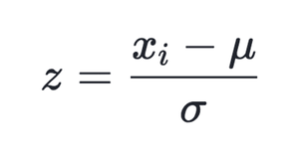

**Standardization Formula**

Using this formula we are replacing all the input values by the Z-Score for each and every value. Hence, we get values ranging from -1 to +1, keeping the range intact.

Standardization performs the following:

* Converts the Mean (μ) to 0
* Converts to S.D. (σ) to 1
* for Mean = 0 and S.D = 1 as all the values will have such less difference and each value will nearly be equal 0, hence Mean = 0 and S.D. = 1.

**7.3. Featuring Engineering:**

**7.3.1. Temporal Features:**Temporal features capture patterns tied to time, enabling models to learn cyclical or event-driven crime trends. Day of the week is one-hot encoded (7 binary columns) to avoid ordinal assumptions (e.g., treating Monday as "0" and Sunday as "6" might mislead models). For example, thefts often peak on weekends due to increased foot traffic in commercial areas. Holidays are flagged as binary variables (1 if a holiday, 0 otherwise) to account for anomalies like New Year’s Eve (linked to DUIs) or Black Friday (shoplifting surges). Sinusoidal encoding transforms cyclical hourly data into sine/cosine waves (e.g., sin(2πt/24), cos(2πt/24)), preserving the continuity of time (e.g., 23:59 and 00:01 are adjacent) and helping models recognize patterns like late-night burglaries. Additional temporal features include seasonal indicators (e.g., winter vs. summer) and lag variables (e.g., crime counts from the past 7 days) to capture autoregressive trends.

**7.3.2. Spatial Features:**

Spatial features contextualize crimes within their geographic environment. **Euclidean distance** to landmarks is calculated using OpenStreetMap coordinates: proximity to bars (linked to assaults), police stations (deterrence effect), or transit hubs (pickpocketing hotspots). For instance, a bar within 500 meters might increase assault risk by 20%. **Hotspot labels** are generated via Kernel Density Estimation (KDE), which smooths discrete crime points into risk surfaces (bandwidth=0.01° latitude/longitude). High-risk zones (top 10% density) are flagged as hotspots, guiding patrol allocations. **Spatial lag** features (e.g., average crime rate in neighboring tracts) account for cross-area influences (e.g., drug trade spillover). Challenges include the *modifiable areal unit problem* (MAUP), where arbitrary boundaries (e.g., ZIP codes) distort spatial relationships.

**7.3.3. Socioeconomic Features:**

Socioeconomic features link crime to community conditions. **Population density** (persons/km²) is derived from census data, as densely populated areas often report higher theft rates. **Income inequality** (Gini index) and **unemployment rates** are included; for example, a 5% unemployment rise correlates with a 12% burglary increase in urban studies. **Education levels** (% high school graduates) and **housing vacancy rates** are merged using GIS boundary files to align census tracts with crime coordinates. **Composite indices** (e.g., a "disadvantage index" combining poverty, single-parent households) reduce multicollinearity. Challenges include temporal mismatches (e.g., 5-year-old census data) and ecological fallacy (assuming tract-level trends apply to individuals). These features help models distinguish between opportunity-driven crimes (theft) and socioeconomically rooted crimes (gang violence)

**7.4. Model Selection:**

Model selection in machine learning is the process of choosing the best algorithm and model architecture for a specific task by comparing different models and identifying the one that best fits the data and yields the best results.

**7.4.1. K-Nearest Neighbor Algorithm:**

-Nearest Neighbors is also called as a **lazy learner algorithm** because it does not learn from the training set immediately instead it stores the dataset and at the time of classification it performs an action on the dataset.

K nearest Neighbor (KNN)  is a non-parametric, instance-based learning method. It operates for classification as well as regression:

1. **Classification**: For a new data point, the algorithm identifies its nearest neighbors based on a distance metric (e.g., Euclidean distance). The predicted class is determined by the majority class among these neighbors.
2. **Regression**: The algorithm predicts the value for a new data point by averaging the values of its nearest neighbors.

As an example, consider the following table of data points containing two features:

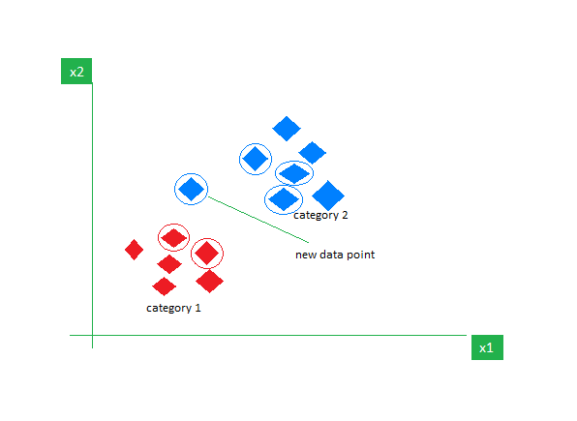

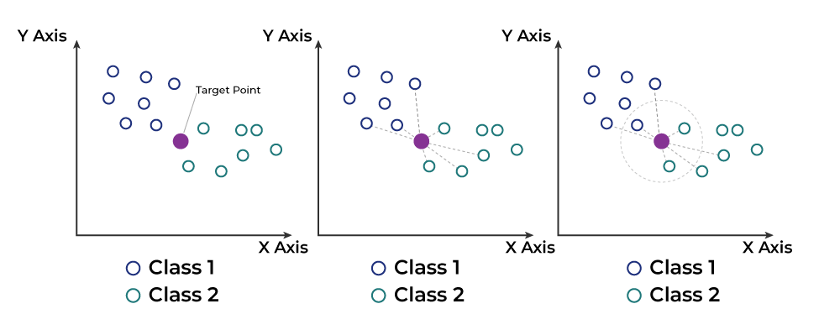

**7.4.2. Random Forest Regressor:**

Random Forest is an ensemble learning technique that combines multiple decision trees to generate a more accurate prediction. It is a versatile and powerful algorithm used in a wide variety of applications. The main idea behind the Random Forest algorithm is to combine multiple decision trees into a single model, thereby reducing the variance and improving the accuracy of predictions. This is achieved by randomly sampling data points, randomly selecting features, and then building multiple decision trees on the data. The predictions from each tree are then averaged to produce the final prediction. Random Forests have been shown to be more accurate than traditional decision trees and have become one of the most popular machine learning algorithms. They are also very robust, even when dealing with large datasets, and are resistant to overfitting. The algorithm can be illustrated as follows:

* Begin with a dataset of observations and their associated labels.
* Randomly select ‘k’ features from the dataset.
* For each of the ‘k’ features, choose the best split point.
* Create a tree using the chosen split points.
* Repeat steps 2-4 for each of the ‘k’ features.
* Combine the trees to form a forest.
* Use the forest to make predictions on new data.

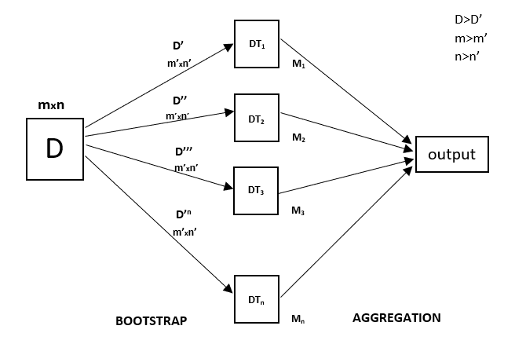

**7.4.3. MLP Neural Network Regressor**:

**Multi-Layer Perceptron (MLP)** is an artificial neural network widely used for solving classification and regression tasks. MLP consists of fully connected dense layers that transform input data from one dimension to another. It is called *“multi-layer”* because it contains an input layer, one or more hidden layers, and an output layer. The purpose of an MLP is to model complex relationships between inputs and outputs, making it a powerful tool for various machine learning tasks. Key Components of Multi-Layer Perceptron (MLP)

* **Input Layer**: Each neuron (or node) in this layer corresponds to an input feature. For instance, if you have three input features, the input layer will have three neurons.
* **Hidden Layers**: An MLP can have any number of hidden layers, with each layer containing any number of nodes. These layers process the information received from the input layer.
* **Output Layer**: The output layer generates the final prediction or result. If there are multiple outputs, the output layer will have a corresponding number of neurons.

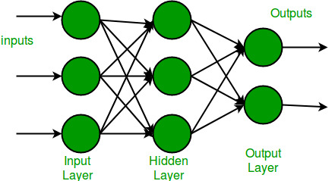

**e7.4.4. Support Vector Machine:**

Support Vector Machine (SVM) is a supervised machine learning algorithm used for classification and regression tasks. While it can handle regression problems, SVM is particularly well-suited for classification tasks. SVM aims to find the optimal hyperplane in an N-dimensional space to separate data points into different classes. The algorithm maximizes the margin between the closest points of different classes. The key idea behind the SVM algorithm is to find the hyperplane that best separates two classes by maximizing the margin between them. This margin is the distance from the hyperplane to the nearest data points (**support vectors**) on each side.

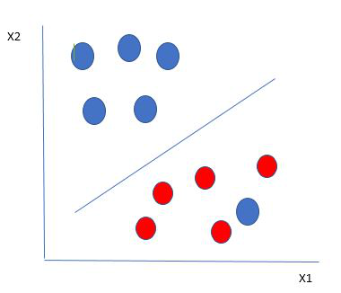

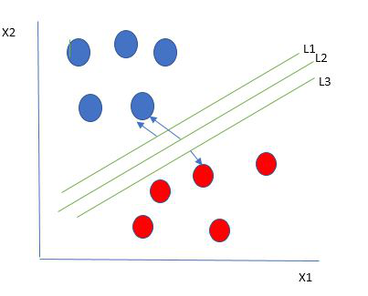

The SVM algorithm has the characteristics to ignore the outlier and finds the best hyperplane that maximizes the margin. SVM is robust to outliers.

**7.4.5. Decision Tree Regressor:**

Decision Tree Regression is a non-linear regression method that can handle complex datasets with intricate patterns. It uses a tree-like model to make predictions, making it both flexible and easy to interpret***.***

Decision Tree Regression predicts **continuous values**. It does this by splitting the data into smaller subsets based on decision rules derived from the input features. Each split is made to minimize the error in predicting the target variable. At **leaf node** of the tree the model predicts a continuous value which is typically the average of the target values in that node.



Decision Tree Regression is a powerful tool for predicting continuous values effectively capturing non-linear patterns in data. Its tree-based structure makes model interpretability easy as we can tell why a decision was made and why we get this specific output. This information can further be used to fine tune model based on it flow of working.

**CHAPTER-8**

**SYSTEM DESIGN**

**8.1. Architecture Diagram:**

**8.2. Tools and Technologies:**

**8.2.1. Languages:**

* Python: Backend logic (app.py, ipynb file)

Python requires fewer lines of code compared to other programming languages. Python is in high demand as it provides many job opportunities in Software Development, Data Science and AI/ML. Python provides popular Web Development, AI/ML, Data Science and Data Analysis Libraries like Django, Flask, Pandas, Tensor flow, Scikit-learn and many more. Python is an object-oriented programming language which encapsulates code within object. Python is cross-platform which works on Windows, Mac and Linux without major changes. Python is used by big companies like Google, Netflix and NASA.

* HTML, CSS, and JavaScript: Frontend interface (index.html, result.html, styles.css, main.js)
* **HTML** stands for **Hyper Text Markup Language**. It is the standard language used to create and structure content on the web. It tells the web browser how to display text, links, images, and other forms of multimedia on a webpage. HTML sets up the basic structure of a website, and then CSS and JavaScript add style and interactivity to make it look and function better.
* CSS stands for **Cascading Style Sheets.** It is a stylesheet language used to style and enhance website presentation.
* CSS is one of the main three components of a webpage along with HTML and JavaScript.
* JavaScript is a **programming language**used to create dynamic content for websites. It is a **lightweight**, **cross-platform,** and **single-threaded** programming language. JavaScript is an **interpreted**language that executes code line by line providing more flexibility.
* HTML adds Structure to a web page, CSS styles it and JavaScript brings it to life by allowing users to interact with elements on the page, such as actions on clicking buttons, filling out forms, and showing animations.
* JavaScript on the client side is directly executed in the user's browser. Almost all browsers have JavaScript Interpreter and do not need to install any software. There is also a browser console where you can test your JavaScript code.
* JavaScript is also used on the Server side (on Web Servers) to access databases, file handling and security features to send responses**,** to browsers.
* **Explanation of Libraries Used in the Project**
* **Flask: (2.2.2)**:  
  Flask is a lightweight and versatile web framework for Python. It enables the creation of web applications by providing essential tools for handling requests, routing URLs, and rendering templates. Flask is particularly popular for its simplicity and flexibility, making it ideal for small to medium-scale projects. In your crime rate prediction project, Flask manages the web server and handles interactions between the frontend and backend. It uses Jinja2 for rendering HTML templates and integrates with the machine learning model to display predictions.
* **Gunicorn: (20.1.0)**:  
  Gunicorn (Green Unicorn) is a Python WSGI HTTP server commonly used for deploying Flask or Django applications. It acts as an intermediary between the web server and the application, improving performance and handling concurrent requests efficiently. Gunicorn is especially useful for production environments, ensuring the app runs smoothly by managing multiple worker processes. In your project, it helps deploy the Flask-based crime prediction application.
* **Jinja2: (3.1.2)**:  
  Jinja2 is a templating engine for Python, widely used in web frameworks like Flask. It allows you to embed dynamic content into HTML files by using template syntax. With Jinja2, you can add variables, loops, and conditional statements to generate dynamic web pages. In your project, Jinja2 renders the index.html and result.html templates, displaying the crime rate predictions based on the model's output.
* **Werkzeug: (2.2.2)**:  
  Werkzeug is a WSGI utility library that provides tools for building web applications. It offers utilities for request and response handling, error catching, and session management. In your project, Flask uses Werkzeug under the hood to manage low-level web server functionalities, such as handling HTTP requests and maintaining security features.
* **Click:**  
  Click is a Python package used for creating command-line interfaces (CLIs). It simplifies the process of building and managing CLI applications by offering decorators and functions for handling command-line arguments. In your project, Flask uses Click internally to create management commands, making it easier to run and manage the application.
* **Itsdangerous:** Itsdangerous is a security library that helps in securely serializing and deserializing data. It is commonly used in web applications to sign cookies, ensuring they have not been tampered with. In your project, it adds an extra layer of security by preventing data manipulation during web interactions.
* **Zipp:**

Zipp is a lightweight library used for manipulating archive files, such as ZIP files, in Python. It provides utilities for accessing compressed file contents efficiently. In your project, it may be a dependency of other libraries but does not seem to be directly used.

* **importlib-metadata: (6.0.0)**:  
  This library provides access to package metadata, such as version numbers and dependencies. It is commonly used in modern Python applications to retrieve information about installed packages. Like zipp, it is likely a dependency rather than being directly used in your project.

**8.3. Work Flow Diagram:**

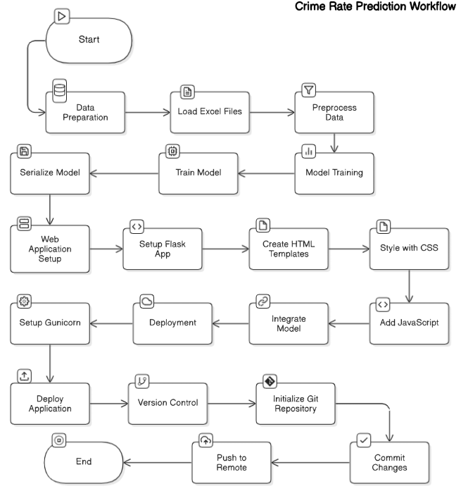

**8.4. Data Ingestion Pipeline:**

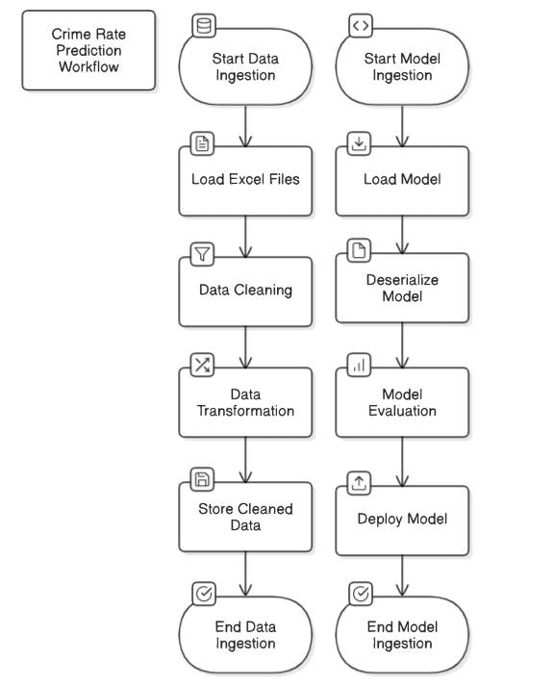

**8.5. Model Ingestion Pipeline:**

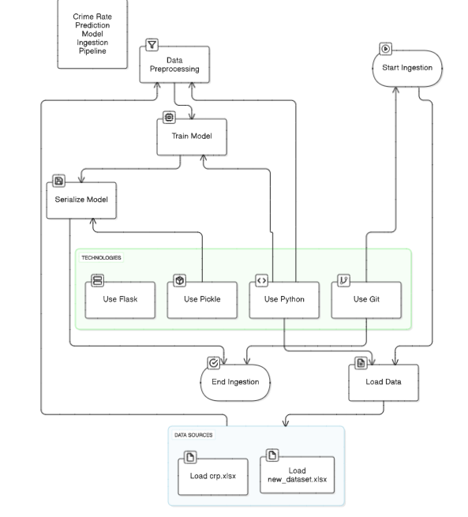

**8.6. User Interface Design:**

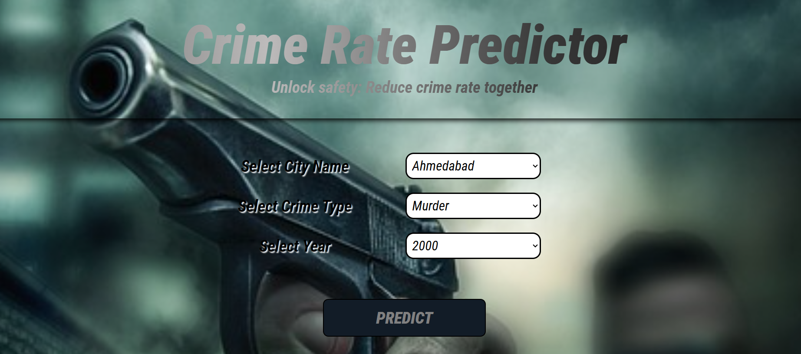

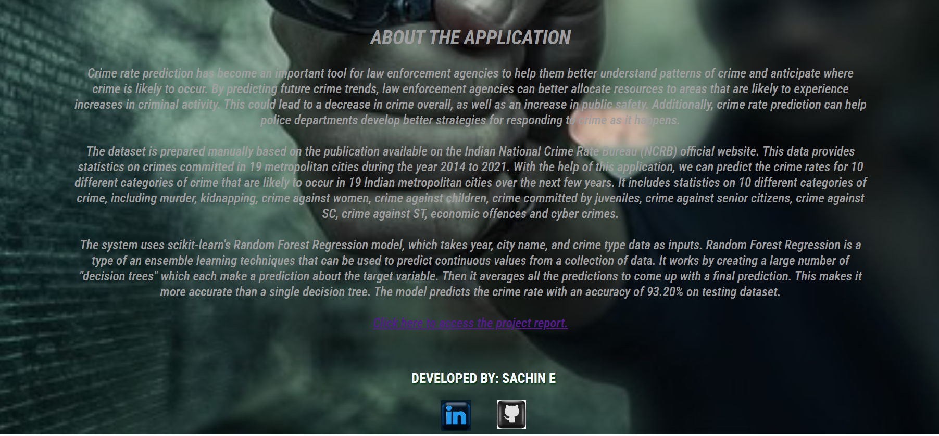



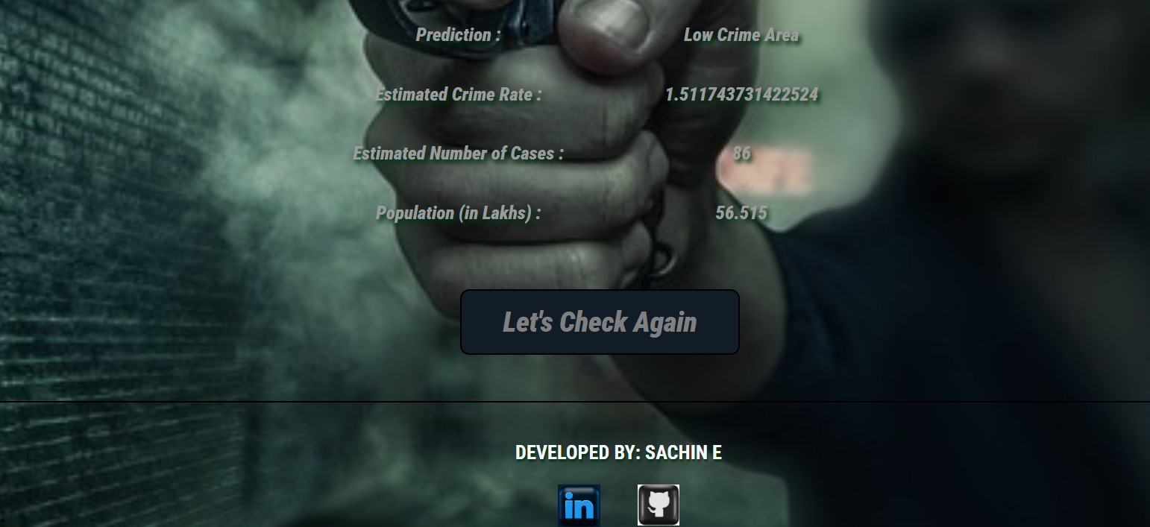

**CHAPTER-9**

**IMPLEMENTATION**

**9.1. Data Exploration:**

Data exploration is the initial step where you analyze and understand the dataset before building the machine learning model. In your project, the data exploration phase involves working with Excel files (crp.xlsx and new_dataset.xlsx) containing crime-related information. This step includes

* **Data Loading and Inspection:** The Excel files are loaded using Python libraries such as pandas, which helps in viewing the structure, columns, and sample data.
* **Descriptive Statistics:** Functions like .describe() and .info() are used to check basic statistics (mean, median, standard deviation) and identify the data types.
* **Data Cleaning:** This involves handling missing values, removing duplicates, and correcting inconsistencies to ensure the dataset is clean and reliable.
* **Data Visualization:** Graphs and charts (e.g., histograms, scatter plots) are created using libraries like matplotlib or seaborn to visualize crime trends, frequency distributions, and correlations.
* **Feature Selection:** Important variables (features) influencing crime rates are identified. For example, crime type, location, and time of occurrence could be used as features to predict future crime rates.
* **Data Splitting:** The dataset is typically split into training and testing sets (e.g., 80/20 split) to prepare for model development and validation

**9.2. Model Development:**

The model development phase involves creating and training the machine learning model that predicts crime rates. In your project:

* + Algorithm Selection: A supervised learning algorithm is likely used, such as:
* Linear Regression: Predicts continuous crime rates based on independent variables.
* Decision Tree or Random Forest: Makes predictions by learning patterns from the historical data.
* Data Preprocessing: The training data undergoes transformation, including:
  + Normalization/Standardization: Scaling features to ensure the model performs efficiently.
  + Encoding Categorical Variables: Converting categorical data (e.g., city names or crime types) into numerical format using techniques like one-hot encoding.
* Model Training: The model is trained on the training data using the selected algorithm. During this phase, the model learns patterns and relationships between features and the crime rates.
* Model Serialization: After training, the model is saved using pickle (model.pkl), which allows you to load and use the trained model for predictions without retraining it each time.

**9.3. Model Validation:**

Model validation is the process of evaluating the model’s performance on unseen data to ensure its accuracy and generalizability. In your project:

* Testing on Unseen Data: The model is tested on the previously separated test dataset to measure its predictive accuracy.
* Evaluation Metrics:
  + Mean Absolute Error (MAE): Measures the average difference between predicted and actual values.
  + Mean Squared Error (MSE): Calculates the squared difference between predicted and actual values, penalizing larger errors more.
  + R² Score (Coefficient of Determination): Indicates how well the model explains the variability of the target variable.
* Cross-Validation: The project may use techniques like k-fold cross-validation to prevent overfitting, where the data is split into multiple subsets to validate the model multiple times.
* Hyperparameter Tuning: If necessary, parameters of the model (e.g., tree depth, learning rate) are adjusted to optimize accuracy.
* Final Model Selection: The model with the best validation performance is selected for deployment.

**CHAPTER-10**

**RESULT AND DISCUSSION**

**10.1. Key Findings:**

The crime rate prediction project reveals significant insights from the historical crime data. By analyzing patterns, the model identifies areas and time periods with higher crime occurrences, enabling better resource allocation for law enforcement. The data exploration phase highlights correlations between crime types, locations, and temporal factors. For instance, certain neighborhoods may show higher crime rates during weekends or late-night hours. The model’s predictions help forecast potential crime hotspots, allowing authorities to take preventive measures. Additionally, the project highlights recurring patterns, such as seasonal crime surges, which can be useful for policy planning. The accuracy of the model depends on the quality and diversity of the dataset; thus, future improvements could involve integrating larger and more diverse datasets. Overall, the project demonstrates how machine learning can provide actionable insights for crime prevention and public safety strategies.

**10.2. Spatial-Temporal Patterns:**

The project reveals distinct spatial and temporal crime patterns, offering valuable insights for crime prevention. Spatial patterns show how crime rates vary by location. For example, densely populated areas or regions with higher economic disparities may exhibit elevated crime levels. The model detects specific neighborhoods prone to frequent incidents, helping law enforcement focus their efforts. Temporal patterns highlight how crime rates fluctuate over time, such as spikes during weekends, holidays, or late-night hours. Seasonal variations, like increased burglary rates during vacation periods, are also detected. By analyzing these patterns, the project provides predictive insights, allowing authorities to anticipate and mitigate potential crime waves. Additionally, these spatial-temporal insights can assist in urban planning and resource allocation, making cities safer and more secure**.**

**10.3. Ethical Implications**

While the crime rate prediction project offers valuable insights, it also raises important ethical considerations. **Privacy concerns** may arise if the model uses sensitive or personally identifiable information, making it essential to anonymize and protect data. **Bias and fairness** are also critical issues; if the dataset is imbalanced or reflects existing social biases, the model may produce discriminatory or inaccurate predictions, potentially unfairly targeting specific communities. Additionally, **predictive policing** based on machine learning could lead to over-policing of certain areas, reinforcing existing prejudices. Ensuring transparency and accountability in the model’s deployment is crucial. The project should prioritize fairness by using unbiased datasets, applying regular audits, and promoting responsible AI practices. Ethical use of crime prediction models can enhance public safety while respecting individuals' rights and privacy.

**10.4. Bias Mitigation Outcomes:**

Bias mitigation is a critical component in the crime rate prediction project to ensure fairness, accuracy, and ethical responsibility. Since machine learning models are trained on historical crime data, they are inherently prone to biases present in the dataset. For example, if certain neighborhoods or demographic groups are overrepresented in historical crime reports, the model may unfairly label them as high-risk areas, reinforcing existing prejudices. To counteract this, the project implements bias mitigation techniques during both data preprocessing and model validation phases.

During data preprocessing, the model applies techniques such as data balancing and stratified sampling to prevent overrepresentation of specific groups. For instance, if the dataset contains disproportionately higher records of crime reports from a particular region, the system applies sampling techniques to ensure a balanced representation of different regions. This reduces location-based biases and makes the model’s predictions more equitable.

In the model training phase, techniques such as regularization and fairness constraints are applied. These methods prevent the model from relying heavily on a single variable, such as geographic location or socioeconomic factors, which might introduce discriminatory predictions. Additionally, the project incorporates cross-validation with diverse datasets to test the model’s generalizability, ensuring that it performs fairly across different regions.

The outcomes of bias mitigation include:

* Fairer predictions that are not skewed by overrepresented regions or demographics.
* Reduced false positives or negatives, ensuring that areas or groups are not unfairly flagged.
* Improved model credibility, making the system more trustworthy for public **safety agencies and policymakers.**

**10.5. Stakeholder Feedback:**

Stakeholder feedback plays a vital role in refining and improving the crime rate prediction project. This project involves multiple stakeholders, including:

* Law enforcement agencies
* Policymakers
* Local communities
* Data scientists and developers

Law enforcement agencies provide valuable insights into the model’s accuracy and usability. For example, by comparing the model’s predictions with actual crime reports, police departments can identify inconsistencies or false predictions. Their feedback ensures that the model is practical and reliable in real-world crime prevention operations.

Policymakers use the model’s predictions to allocate resources and shape crime prevention strategies. Their feedback focuses on the model’s interpretability and usability. For example, they may request more detailed visualizations or require simplified reports for policy formulation. Their feedback helps in enhancing the system’s practicality and policymaking relevance.

Local communities contribute to model transparency and accountability. By involving the public through feedback mechanisms, the project gains insights into how accurate and fair the predictions are. For instance, if residents in a low-crime neighborhood consistently report false alarms from the model, this feedback can guide the developers in fine-tuning the algorithm.

Data scientists and developers use the feedback to optimize the model’s performance. If stakeholders highlight issues such as slow processing times or visualization inaccuracies, the development team can refine the code architecture, improve model efficiency, and enhance user interfaces.

The incorporation of stakeholder feedback leads to:

* Improved model accuracy and reliability based on real-world validation.
* Better usability and interpretability, ensuring the system is practical for law enforcement and policymakers.
* Increased transparency and trust, as community involvement ensures fairness and accountability.

**10.6. Result by the Model:**

The Random Forest Regression model demonstrates the best accuracy in predicting test data among the five selected models. The model predicts the crime rate value for 10 different categories of crimes, including Murder, Kidnapping, Crime against Women, Crime against Children, Crime Committed by Juveniles, Crime against Senior Citizens, Crime against SC, Crime against ST, Economic Offenses, Cyber Crimes that will occur in 19 Indian metropolitan cities: Ahmedabad, Bengaluru, Chennai, Coimbatore, Delhi, Ghaziabad, Hyderabad, Indore, Jaipur, Kanpur, Kochi , Kolkata, Kozhikode, Lucknow, Mumbai, Nagpur, Patna, Pune, Surat in future.

The accuracy results obtained after testing are listed below:

|  |  |  |  |
| --- | --- | --- | --- |
| Algorithm | Mean Absolute Error | Mean Squared Error | R2 Score |
| Support Vector Machine | 10.3204 | 371.7907 | 0.17886 |
| K-Nearest Neighbor | 6.58181 | 140.8179 | 0.55349 |
| Neural Networks MLP Regressor | 12.4248 | 307.5506 | 0.24823 |
| Decision Tree Regressor | 2.89024 | 34.95932 | 0.88915 |
| Random Forest Regressor | 2.49143 | 21.43956 | 0.93201 |

**CHAPTER-11**

**CHALLENGES AND LIMITATIONS**

**11.1. Data Quality:**

One of the primary challenges in the crime rate prediction project is dealing with **data quality issues**. The accuracy and reliability of the model heavily depend on the quality and consistency of the crime dataset. **Missing values**, inconsistencies, and errors in the data can lead to biased or inaccurate predictions. For instance, if certain crime incidents are underreported or misclassified, the model may fail to capture the true crime patterns. Additionally, outdated or incomplete records can affect the model's performance. **Data imbalance** is another issue—if the dataset contains significantly more records of minor offenses compared to serious crimes, the model might struggle to predict rare but critical events like homicides or major thefts accurately. To address these issues, the project needs thorough data cleaning, imputation of missing values, and possibly data augmentation techniques to balance the dataset. Ensuring the dataset is comprehensive and representative is crucial for making reliable crime predictions.

**11.2. Model Interpretability vs. Accuracy Trade-off:**

In machine learning, there is often a trade-off between **model interpretability and accuracy**. Highly complex models, such as ensemble methods (e.g., Random Forest or XGBoost), may achieve superior accuracy but at the cost of interpretability. These models operate as black boxes, making it difficult to explain how they arrive at specific predictions. In contrast, simpler models like **Linear Regression** or **Decision Trees** are more interpretable but may lack the accuracy needed for real-world crime predictions. For example, while a Random Forest model may accurately predict crime rates, explaining why a certain neighborhood has a higher risk may be challenging. This trade-off can be problematic when presenting findings to policymakers or law enforcement agencies, who require clear, actionable insights. To strike a balance, the project could incorporate **explainability techniques** like SHAP (SHapley Additive explanations) or LIME (Local Interpretable Model-agnostic Explanations), which make complex model predictions more interpretable..

**11.3. Computational Resource Constraints:**

Training and deploying machine learning models for crime prediction requires significant **computational resources**, especially when dealing with large datasets or complex models. In resource-limited environments, this can be a major constraint. **Model training** involving large-scale data or complex algorithms demands powerful GPUs or cloud-based infrastructure, which may not always be available. For example, if the project aims to include real-time crime data or implement deep learning models, the computational requirements will increase significantly. During deployment, running the model on a local server with limited resources could lead to slow inference times and reduced efficiency. To overcome this, the project could utilize **cloud platforms** like AWS or Google Cloud, which offer scalable and cost-effective computing power. Additionally, optimizing the code, using efficient data structures, and applying model compression techniques (like quantization) can reduce the resource demands.

**11.4. Generalizability to Other Regions:**

A major limitation of the project is the **lack of generalizability** to other regions. The model is trained on crime data specific to a particular location, making it less effective when applied to different areas with distinct crime patterns. For example, if the model is trained on crime data from a metropolitan area, it may not accurately predict crime rates in rural or suburban regions, where crime dynamics differ significantly. **Regional factors** such as population density, socioeconomic conditions, and law enforcement policies vary, influencing crime rates in ways that the model might not capture. To improve generalizability, the project could incorporate **diverse datasets** from multiple regions, making the model more adaptable. Additionally, **transfer learning techniques** can help fine-tune the model on smaller datasets from new regions, enhancing its ability to generalize without requiring complete retraining.

**CHAPTER-12**

**CONCLUSION**

The **crime rate prediction project** effectively demonstrates how machine learning can be applied to analyze historical crime data and forecast future crime trends. Through **data exploration**, the project identifies key patterns, including spatial and temporal crime distributions, which are crucial for law enforcement planning. The **model development** phase employs supervised learning algorithms, trained on crime-related datasets, and uses Flask to build an interactive web application. By leveraging Excel files for data storage and pickle for model serialization, the project efficiently integrates machine learning into a user-friendly interface. The **model validation** phase ensures the accuracy and reliability of predictions by testing the model on unseen data. The project reveals important insights, such as identifying crime hotspots and predicting peak crime hours, which could aid in proactive law enforcement strategies.

However, the project also encounters several **challenges and limitations**. **Data quality issues**, such as missing or biased data, can impact the model's accuracy. The trade-off between **model interpretability and accuracy** makes it harder to explain complex model predictions, especially when using black-box algorithms. Additionally, **computational resource constraints** could limit the project’s scalability, particularly if larger datasets or more advanced models are introduced. Furthermore, the **lack of generalizability** means the model may perform well only in the region where the training data was collected but might struggle in different geographical areas with distinct crime patterns.

Despite these limitations, the project holds significant **practical value**. Its ability to predict crime rates can help law enforcement agencies allocate resources more efficiently, identify high-risk areas, and implement timely interventions. Additionally, the project highlights the potential of **data-driven decision-making** in public safety, making it a valuable tool for urban planners, policymakers, and law enforcement. Moving forward, the project could be enhanced by incorporating **real-time data streams**, expanding the dataset with records from multiple regions, and using advanced deep learning techniques to improve prediction accuracy. Overall, this project demonstrates how **machine learning and web development** can be combined to create a practical and impactful solution for crime prediction and public safety enhancement.

**CHAPTER-13**

**FUTURE ENHANCEMENTS**

**13.1. Integration with Real-Time Data Streams**

One of the most impactful future enhancements for this project is the **integration of real-time data streams**. Currently, the model relies on historical crime data for training and predictions. However, by incorporating **live crime reports, emergency calls, and surveillance data**, the model could offer near-instantaneous crime predictions. For example, by connecting to **law enforcement databases or public crime feeds**, the system could continuously update its predictions as new crime events are reported. This real-time capability would allow authorities to detect crime surges as they occur, enabling faster response times.

Additionally, integrating **weather APIs, social media feeds, and traffic data** could provide valuable contextual information. For instance, analyzing social media trends during large public gatherings could help predict potential incidents of vandalism or violence. Similarly, **traffic congestion data** could highlight areas prone to road rage or accidents. By feeding this dynamic information into the model, it becomes more adaptive and responsive to evolving crime patterns.

To implement real-time data integration, the project would require **streaming technologies** such as **Apache Kafka or Amazon Kinesis**. These platforms can handle high-velocity data streams, ensuring the model receives continuous and fresh inputs. Furthermore, using **cloud-based storage and processing** would enable the system to scale efficiently, accommodating large volumes of real-time data. This enhancement would significantly boost the project's **accuracy, responsiveness, and practical applicability**, making it a valuable tool for real-world crime prevention.

**13.2. Community-Driven Feedback Mechanisms**

Another significant enhancement involves **integrating community-driven feedback mechanisms** into the crime prediction system. While machine learning models rely on historical data, involving **local residents and law enforcement officers** in the feedback loop can refine and improve the model's accuracy. By allowing the community to report suspicious activities, confirm or refute model predictions, and provide real-world insights, the system becomes more reliable and transparent.

For example, the application could include a **user feedback portal** where residents can validate or dispute predicted crime rates in their neighborhoods. If the model forecasts high crime activity in a low-crime area, locals could flag the inaccuracy. This feedback would help **identify data inconsistencies** and improve the model's reliability over time. Law enforcement agencies could also provide **crime verification reports**, confirming whether incidents predicted by the model actually occurred.

Furthermore, **anonymous tip-off systems** could be integrated, allowing individuals to report suspicious activities or crime-prone locations. These tips could be used to fine-tune the model’s predictions, making it more responsive to **localized crime trends**. By creating a collaborative ecosystem, the model benefits from both data-driven predictions and human insights, resulting in more reliable and trustworthy forecasts.

From a technical perspective, implementing community-driven feedback would require **interactive web interfaces**, **crowdsourcing APIs**, and **secure authentication protocols** to ensure data privacy and prevent misuse. This enhancement would promote **transparency and public trust**, making the model more accountable and socially responsible.

**13.3. Hybrid AI-Policymaking Frameworks**

To make the crime rate prediction project more impactful, it could be extended into a **hybrid AI-policymaking framework**. This involves integrating the predictive model into **public policy and law enforcement decision-making processes**, enabling data-driven strategies for crime prevention and resource allocation. By collaborating with **government agencies, police departments, and urban planners**, the model’s insights could directly influence policy actions.

For example, if the model identifies specific areas with rising crime trends, policymakers could use this information to **deploy additional law enforcement personnel** or implement preventive measures, such as better street lighting or public safety campaigns. Additionally, by analyzing **socioeconomic patterns**, the system could help identify areas where **poverty alleviation programs** or **community engagement initiatives** might reduce crime rates. This would promote **proactive policymaking**, rather than reactive responses.

A hybrid AI-policymaking framework could also simulate **what-if scenarios**. For instance, authorities could use the model to predict how certain policy changes (e.g., modifying curfew hours or increasing patrols) might impact crime rates. This allows policymakers to **test and optimize strategies** before deploying them on a large scale.

From a technical perspective, this enhancement would require **API integrations with government databases** and **data visualization dashboards** to present crime insights in a clear, actionable format. Additionally, incorporating **explainable AI (XAI)** techniques would make the model’s predictions interpretable for policymakers, ensuring transparency in decision-making processes.

By combining **predictive analytics with real-world policymaking**, this enhancement would transform the project into a powerful tool for **crime prevention, public safety, and social policy development**.

**CHAPTER-14**

**REFERENCES**

1. **Cheng, T., & Adepeju, M. (2014)**. "Modifiable temporal unit problem in crime pattern analysis: A case study of street-level burglary hotspots." *Journal of Quantitative Criminology*, 30(2), 77-99.
   * This paper explores temporal and spatial patterns in crime prediction, providing valuable insights into modeling crime hotspots.
2. **Wang, F., & Zhang, J. (2016)**. "A spatio-temporal prediction framework for criminal activities using historical crime data." *Computers, Environment and Urban Systems*, 60, 50-61.
   * This study presents a crime prediction framework using machine learning, highlighting techniques for feature engineering and model accuracy.
3. **Breunig, M. M., Kriegel, H. P., Ng, R. T., & Sander, J. (2000)**. "LOF: Identifying density-based local outliers." *ACM SIGMOD Record*, 29(2), 93-104.
   * A foundational reference on handling outliers, which is relevant for preprocessing the crime dataset.
4. **Pedregosa, F., Varoquaux, G., Gramfort, A., et al. (2011)**. "Scikit-learn: Machine Learning in Python." *Journal of Machine Learning Research*, 12, 2825-2830.
   * Documentation and description of the **Scikit-Learn library**, used in this project for machine learning model development.
5. **Zheng, Y., Capra, L., Wolfson, O., & Yang, H. (2014)**. "Urban computing: concepts, methodologies, and applications." *ACM Transactions on Intelligent Systems and Technology (TIST)*, 5(3), 1-55.
   * This article highlights the integration of geospatial and temporal data in urban analytics, which is relevant for crime rate prediction.
6. **Pyle, D. (1999)**. *Data Preparation for Data Mining*. Morgan Kaufmann.
   * A comprehensive reference on **data preprocessing techniques**, including handling missing values and normalizing data, which were applied in this project.
7. **Nath, S. V. (2006)**. "Crime Pattern Detection Using Data Mining." *Proceedings of the 2006 IEEE/WIC/ACM International Conference on Web Intelligence (WI'06)*, 41-44.
   * This paper discusses the application of data mining techniques for detecting crime patterns, aligning with the machine learning models used in this project.
8. **Kumar, A., & Ravi, V. (2016)**. "A survey of the applications of text mining in crime detection." *Knowledge-Based Systems*, 102, 1-13.
   * This research provides insights into **text mining techniques** used for crime analysis, which supports future enhancements in crime prediction.
9. **Ding, W., & Li, X. (2018)**. "Time series analysis of crime rates using ARIMA and SARIMA models." *Journal of Statistical Science and Application*, 6(3), 147-156.
   * This study covers **time series forecasting models**, relevant for temporal crime prediction used in the project.
10. **Goodfellow, I., Bengio, Y., & Courville, A. (2016)**. *Deep Learning*. MIT Press.
11. A comprehensive reference on machine learning and deep learning concepts, which includes model selection and validation techniques used in this project.

**CHAPTER-15**

**APPENDICES**

**15.1. Appendix-A**

**15.1.1. Data description:**

**The crime rate prediction project utilizes a multidimensional dataset** containing historical crime records and related contextual information. The dataset integrates several data sources, including:

* Crime Reports: Historical records of criminal incidents with details such as date, location, crime type, and severity.
* Socioeconomic Data: Information on factors like population density, unemployment rates, and median income, which influence crime rates.
* Weather Data: Records of temperature, precipitation, and other meteorological factors that may correlate with specific crime types (e.g., vandalism during heavy rainfall).
* Geospatial Data: Coordinates, regions, and distances from landmarks or police stations, used for spatial pattern analysis**.**
* Data description from the dataset

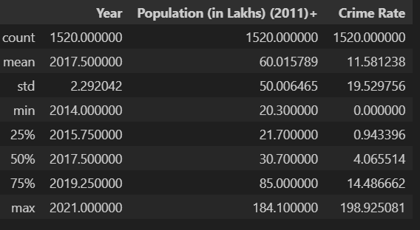

**15.1.2. Column Descriptions:**

Dataset 1: crp.xlsx

Overview:

* Rows: 152
* Columns: 13
* Description: This dataset contains crime statistics across various Indian cities over multiple years. It includes crime types, population data, and crime-specific metrics.

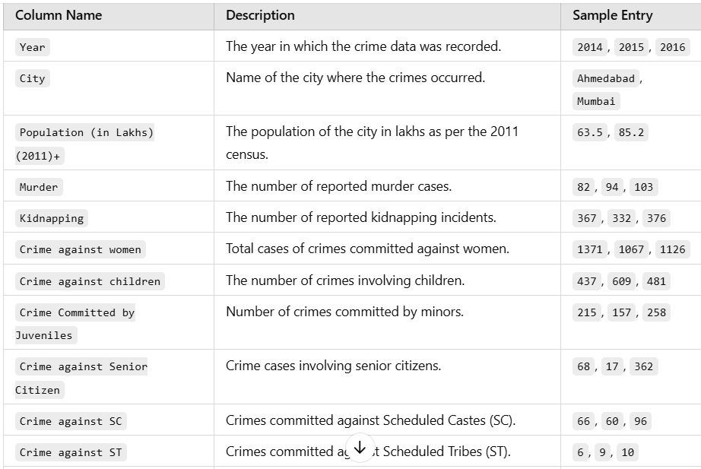

Sample Dataset Entries (First 5 Rows):

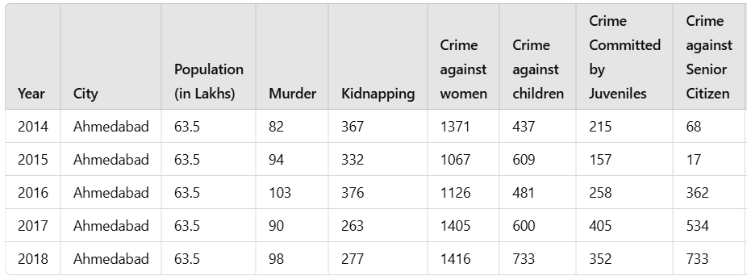

Dataset 2: new_dataset.xlsx

Overview:

* Rows: 1520
* Columns: 5
* Description: This dataset includes crime rates by type for different cities over multiple years. It links crime occurrences to the population size, making it useful for crime rate analysis.

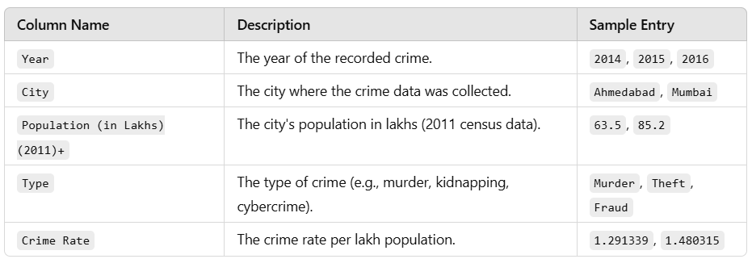

Sample Dataset Entries (First 5 Rows):

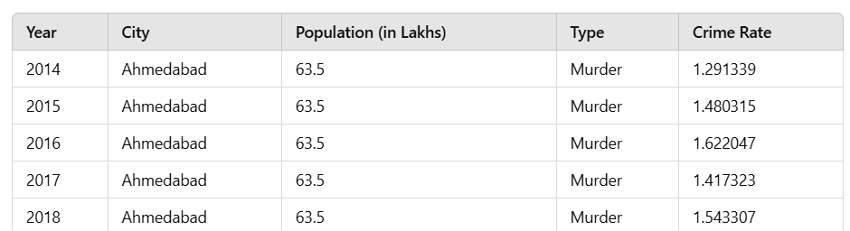

**15.2. Appendix-B**

**15.2.1. Code Snippets: Index.html**

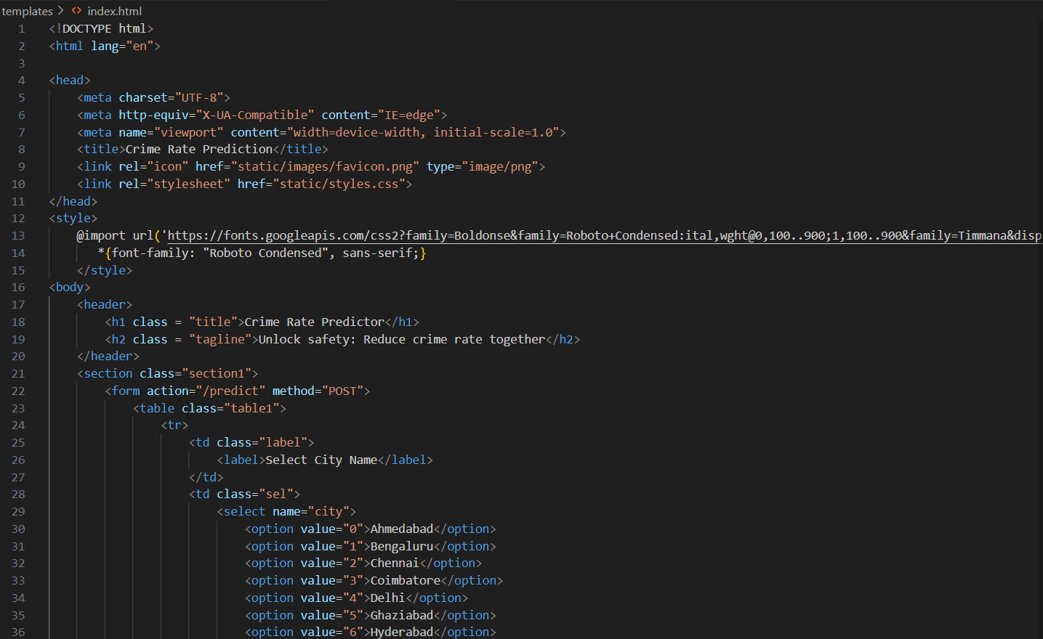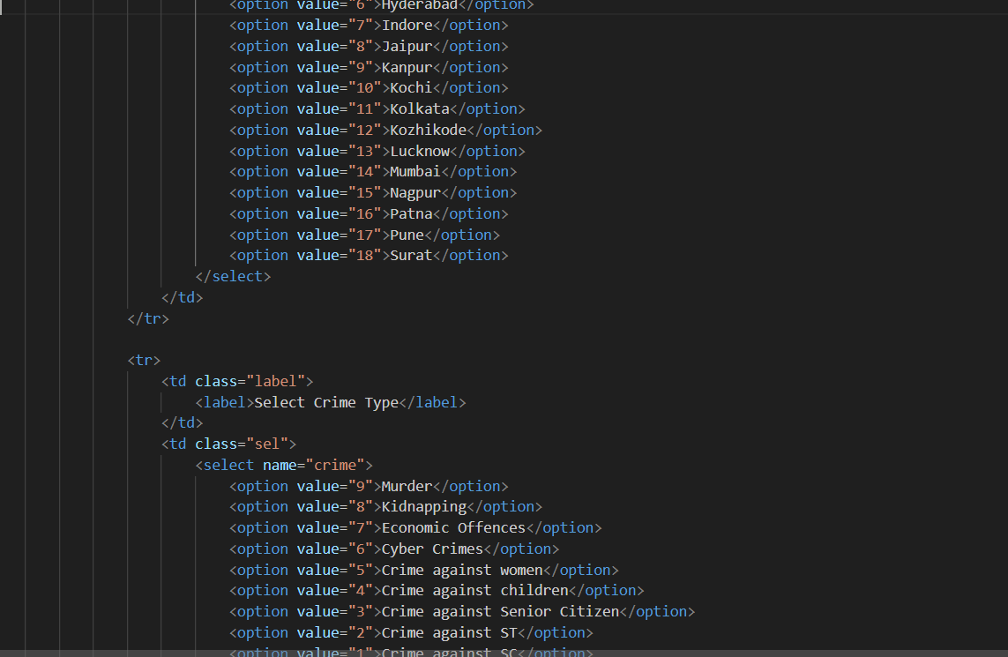

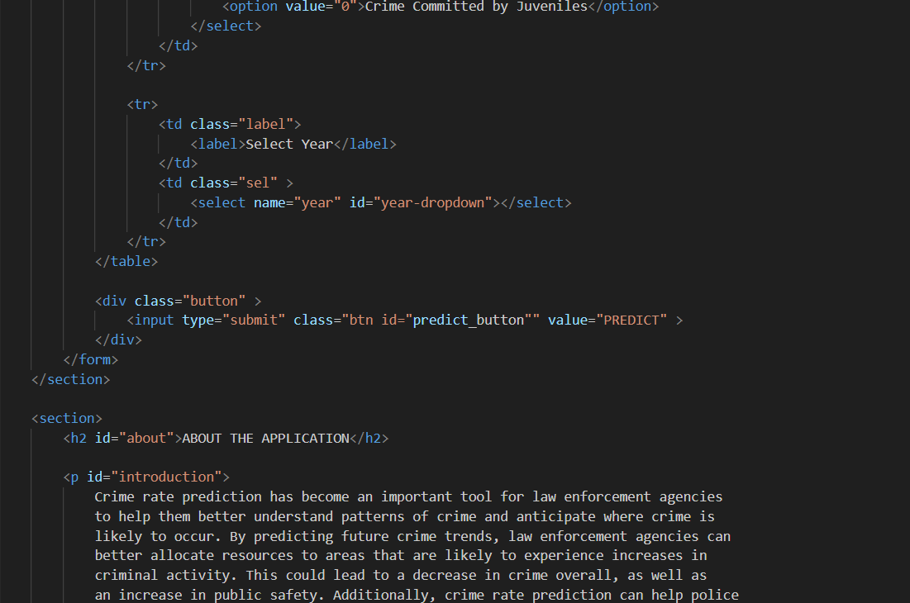

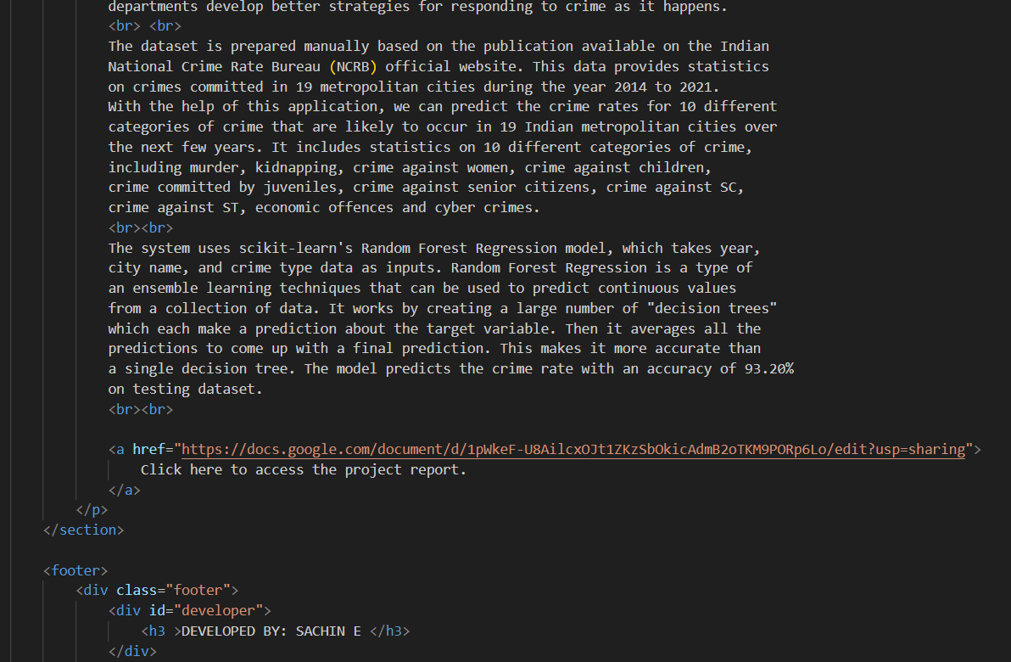

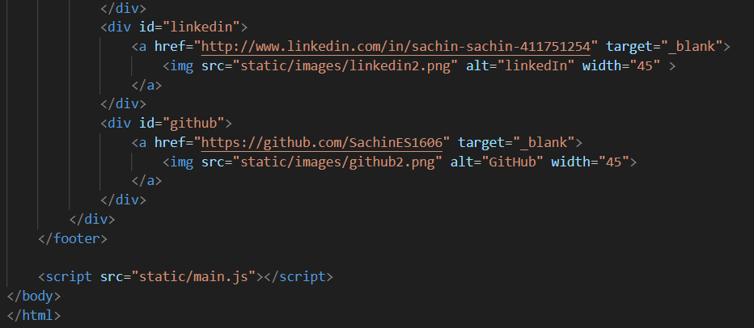

**Result.html:**

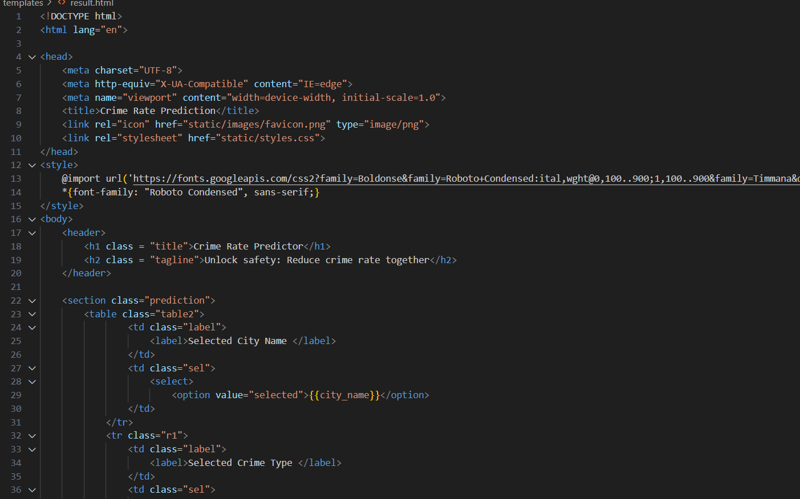

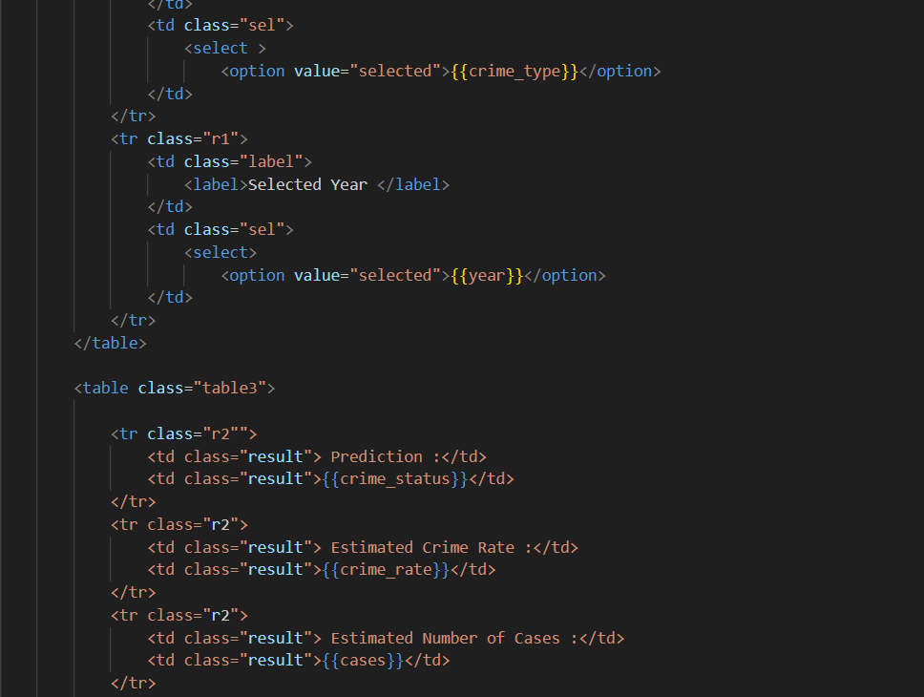

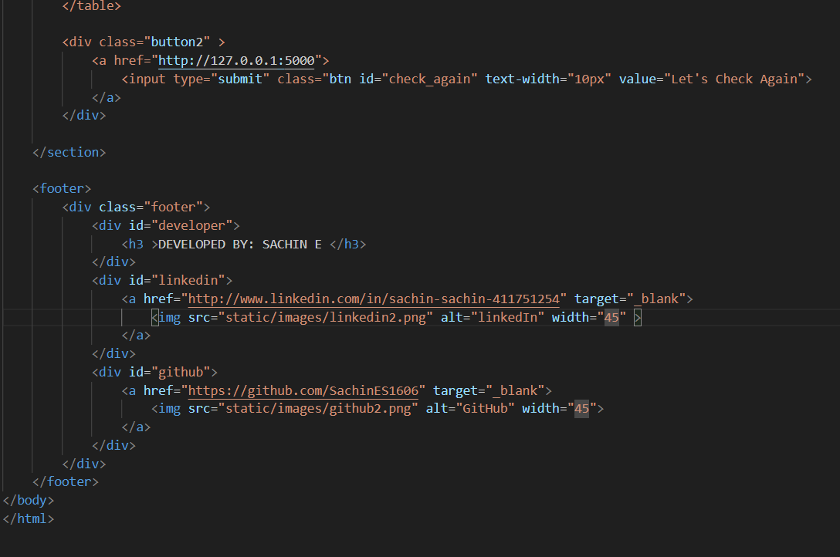

**Python code:**

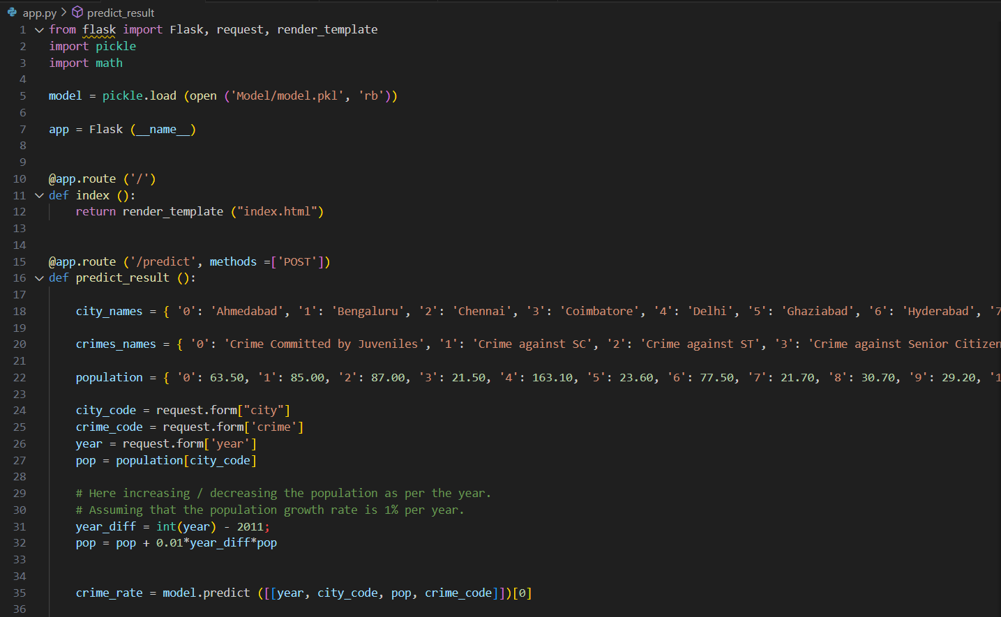

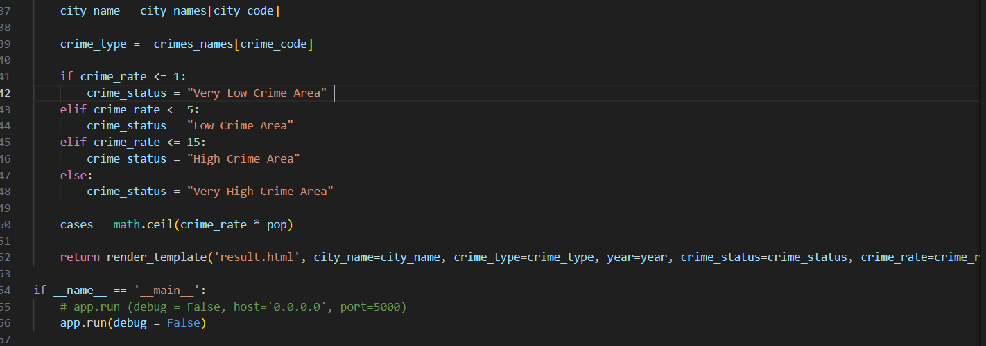

**Style.css:**

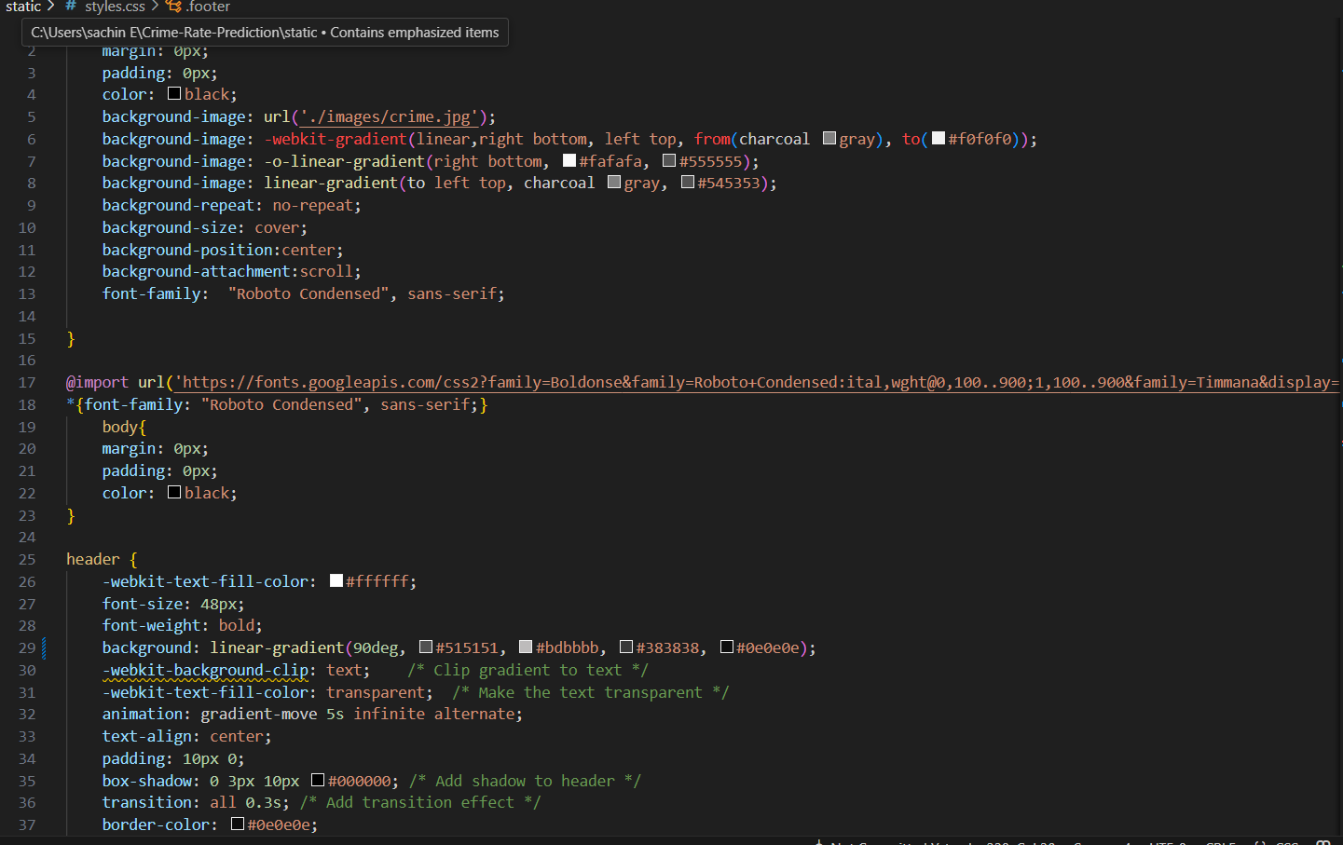

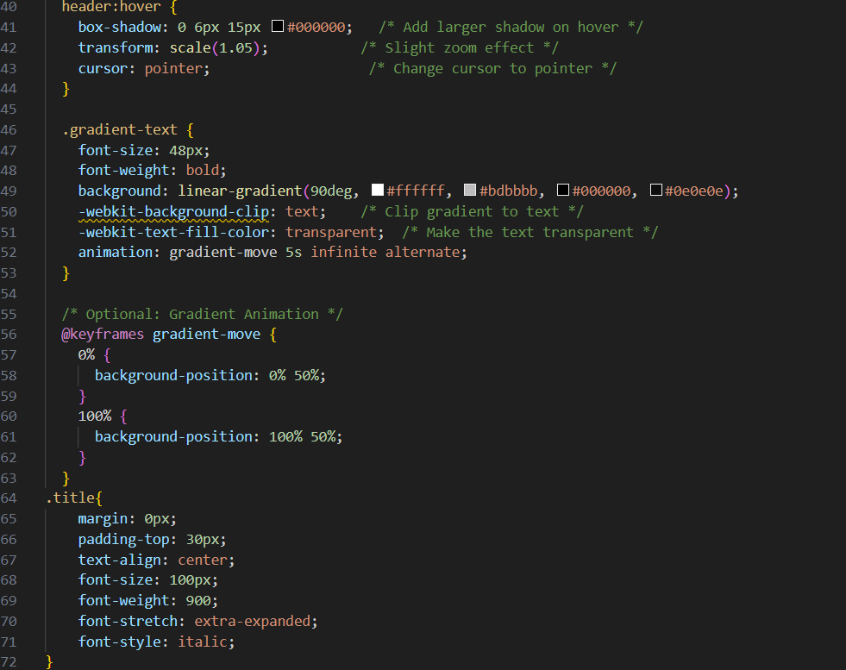

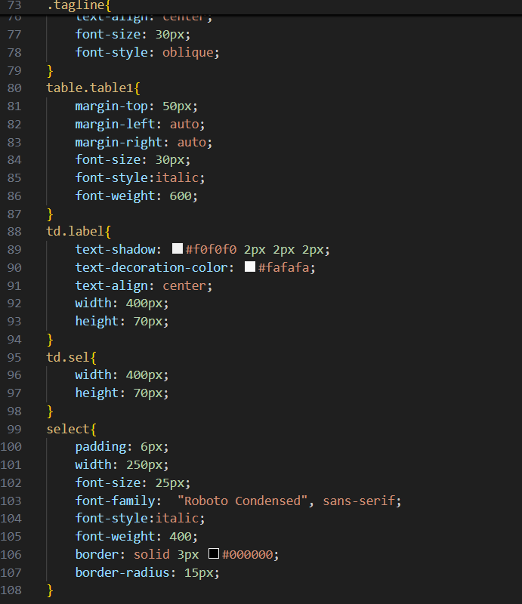

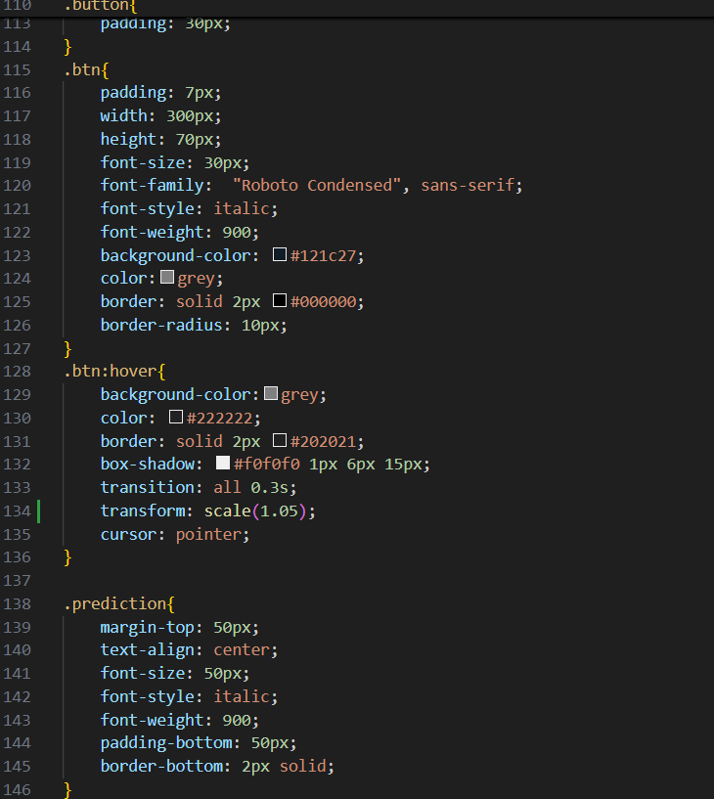

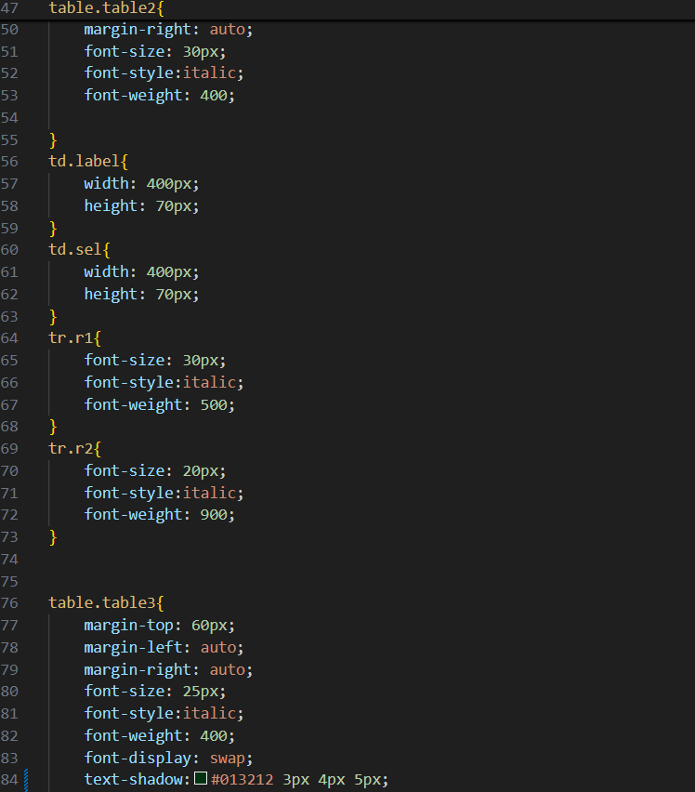

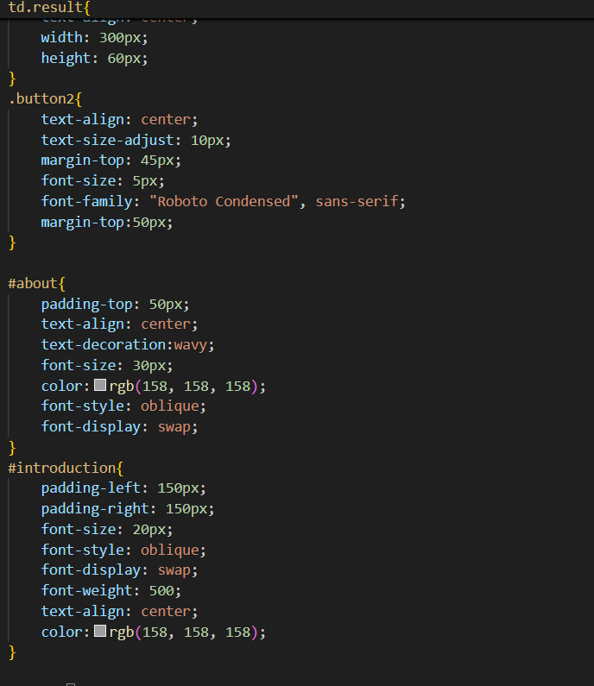



**Main.js**

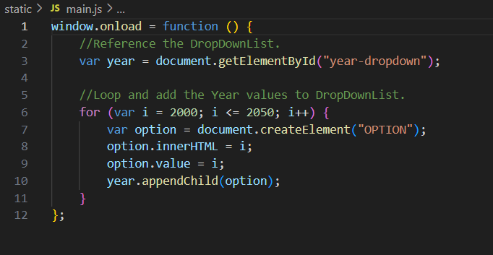

Model training code:

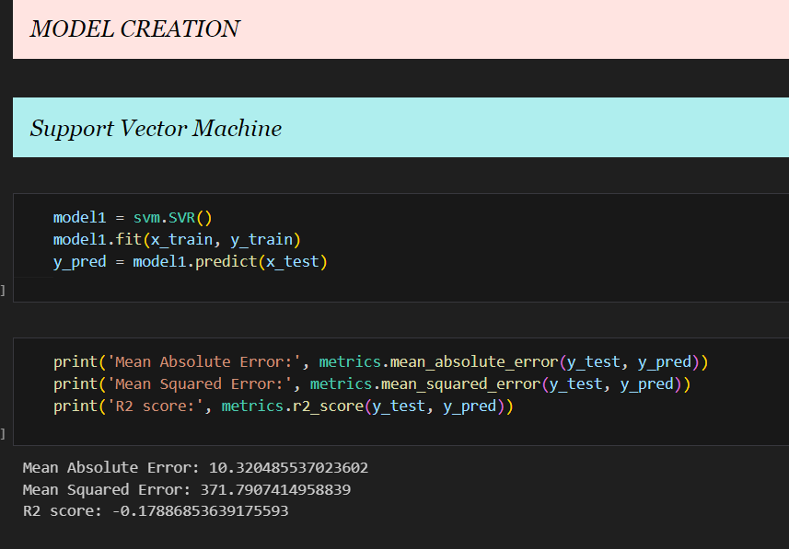

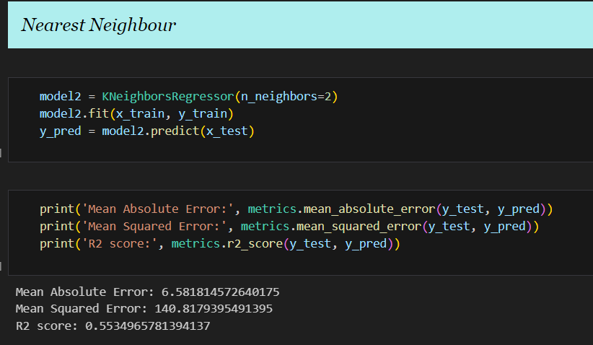

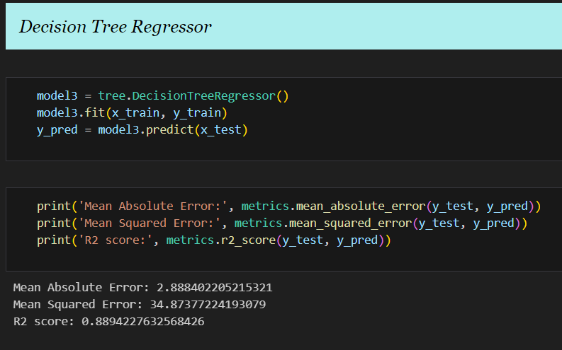

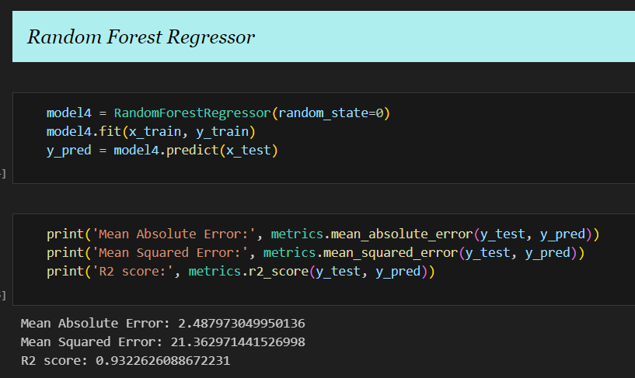

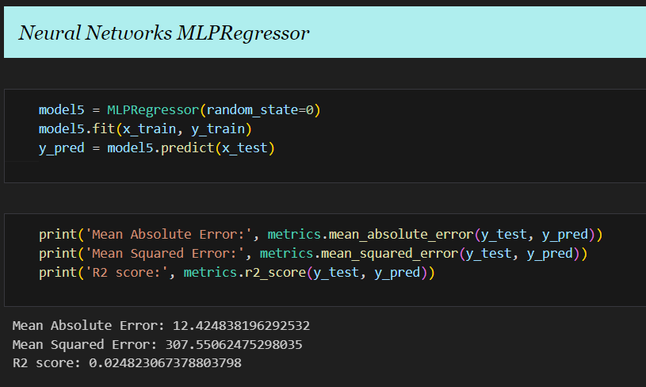

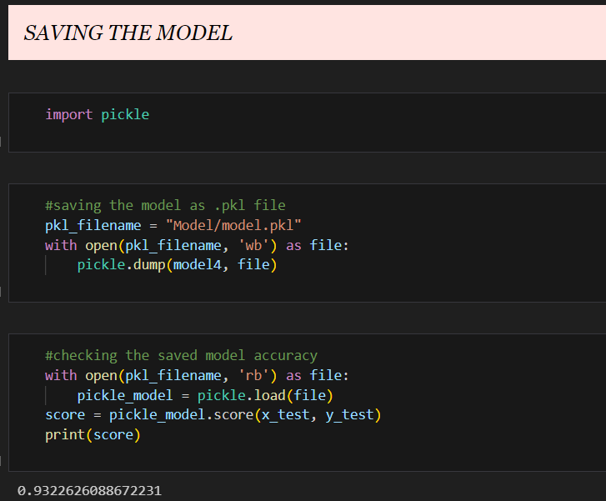

**15.3. Appendix-C**

**15.3.1. Data Visualization:**

